Uploading an Assignment in Blackboard

I demonstrate a method for uploading assignments in Blackboard. I have a Macintosh and my screen captures include parts of the Macintosh desktop that are not really relevant—simply concentrate on the Blackboard window. The following commands assume that you have already completed the assignment and have saved it as a file on your laptop.

After logging into Blackboard, your “My USC” screen should appear with a list of your courses in the scrolling window on the right. If My USC is not displaying, simply select it from the menu bar at the top of the screen; on my display it is highlighted in Gamecock garnet. Then select the appropriate course from among the course selections.

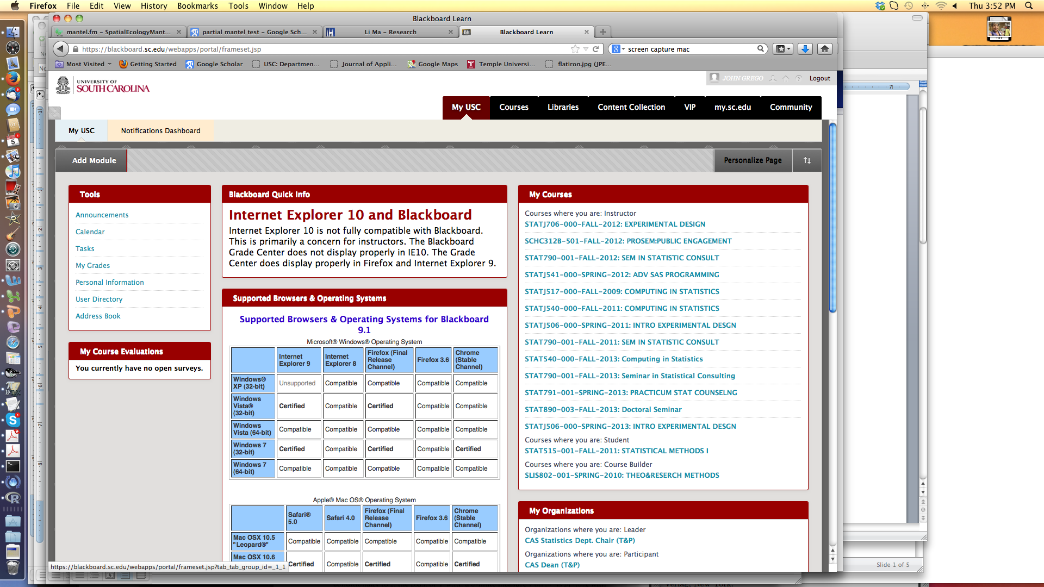

Here we are in STAT 540 Fall 2013. Select Assignments from the window in the upper left (the window has a black background in this example).

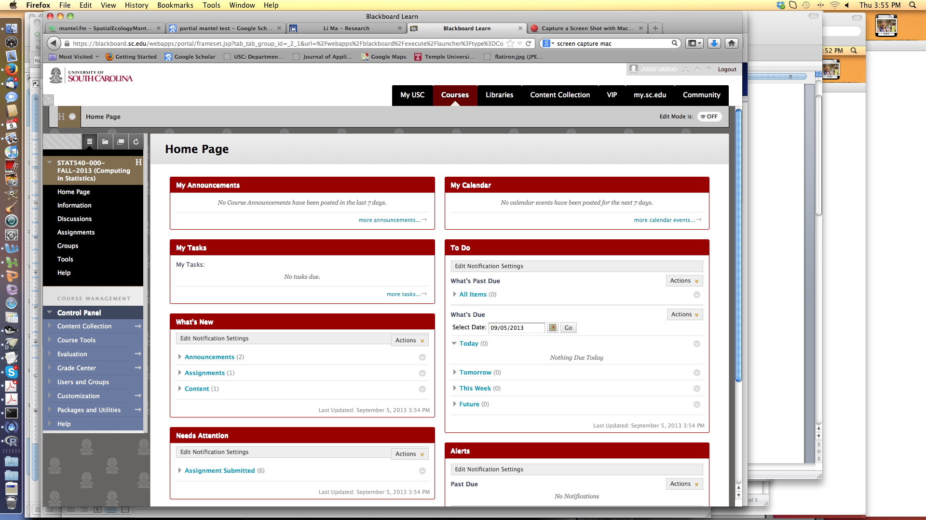

You should see only the assignments that are currently active. In this example, Class Exercise 2, the only active assignment, is due in a few days.

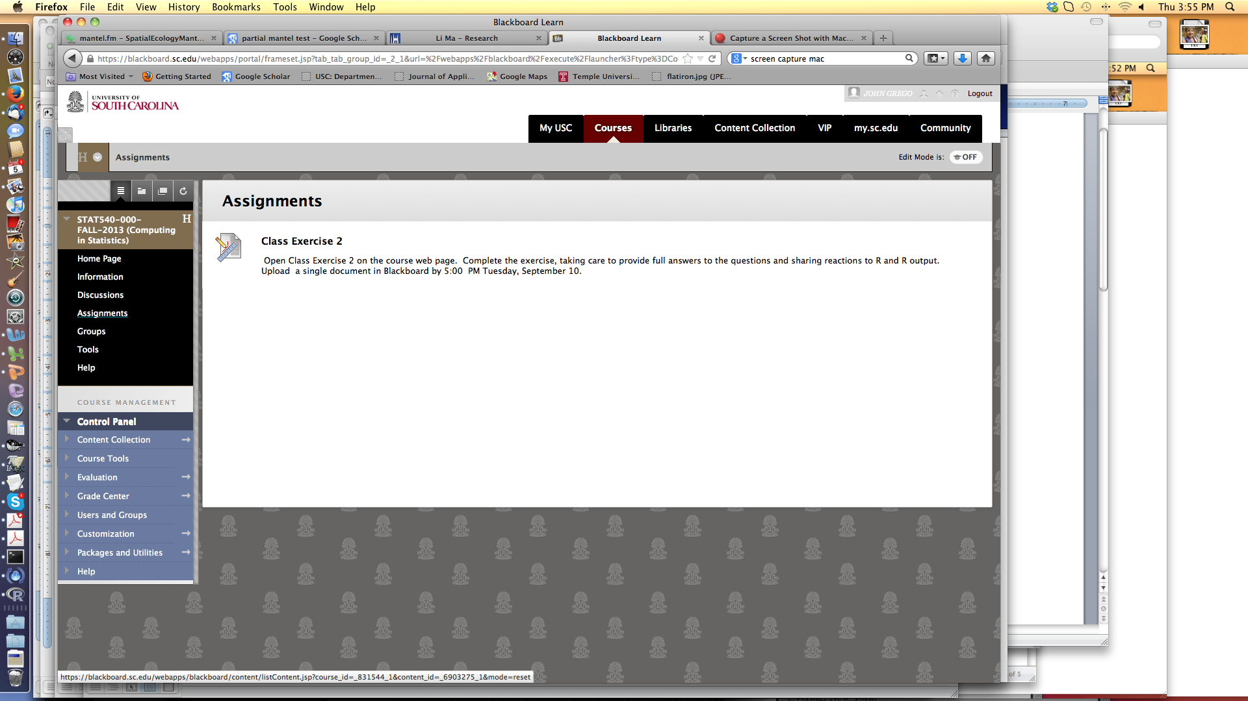

To submit the assignment, you need to click directly on the assignment name (Class Exercise 2, in this case). When you do so, you ‘ll see the following window.

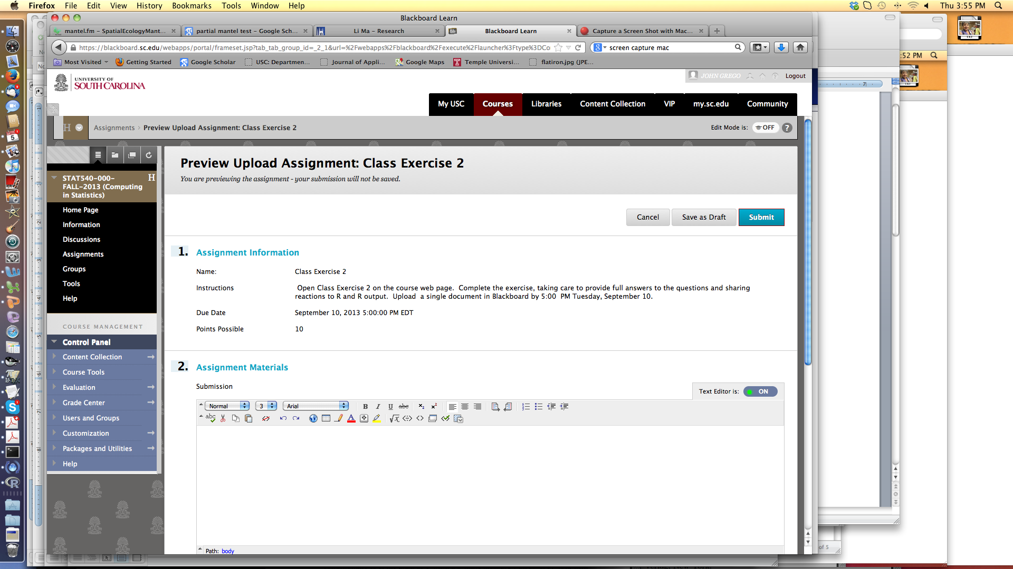

I needed to scroll down a little to attach my file. Select Browse Content Collection…
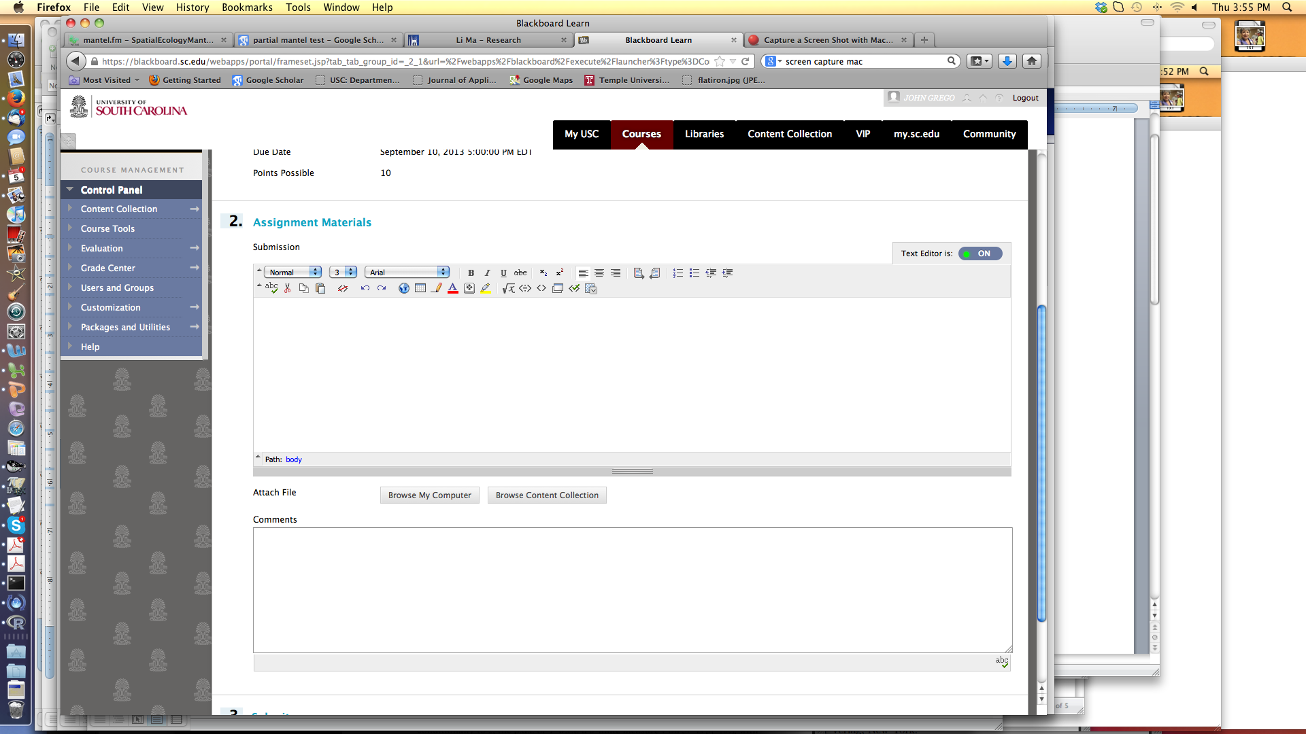

…and then select your file. I’m uploading one of my screen captures here.

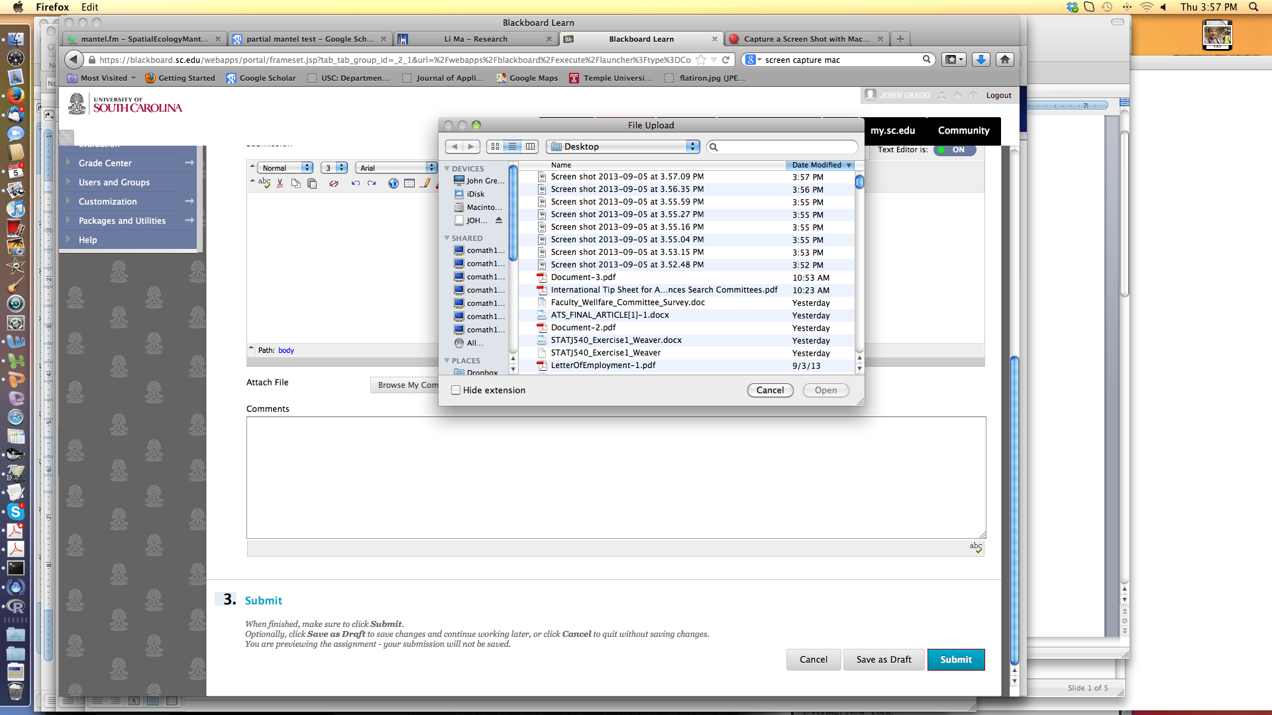

Sometimes students enter comments in the dialog box, but I usually don’t review those comments. After uploading the file, be sure to hit the Submit button at either the top or bottom of the screen.

