STAT 530 HW 2 Fall 2025 Example Solutions
1) Star plot: Answers will vary greatly. From the star plot, the similarity of cities like Canton, OH and Cleveland, OH is apparent. Birmingham, AL and New Orleans, LA, both have quite high Nonwhite populations and Mortality rates. Portland, OR and Seattle, WA have similar stars, with high values for rainfall and education and low values for the pollution variables.
Chernoff Faces:
Key: [1,] "Rainfall" "Face height"
[2,] "Education" "Face width"
[3,] "Popden" "Face shape"
[4,] "Nonwhite" "Mouth height"
[5,] "NOX" "Mouth width"
[6,] "SO2" "Smile curve"
[7,] "Mortality" "Eyes height"

Similar things can be seen from the Chernoff faces. One interesting thing is the wide mouth of Los Angeles, indicating a high NOX level. Denver, CO and Minneapolis, MN have wide faces, indicating high education levels. York, PA and Reading, PA, have lower education levels, as evidenced by the narrow faces.
2) From the scatterplot matrix below, we see that SO2 and Mortality seem strongly positively associated. Nonwhite population and Mortality also have a strong positive association. Education seems somewhat negatively associated with both Rainfall and Mortality. NOX doesn’t seem to be strongly associated with any variables, but there do seem to be some cities that have high outlying values of NOX.
Problem 3)
Below are just a few chiplots as examples: From the following chiplots, we see that SO2 and mortality are positively associated (since many dots fall above the central region in the chiplot). Nonwhite percentage and NOX are close to independent, since most points fall within the central region. And education and rainfall seem negatively associated, since most points fall below the central region.

4) We see that Education and Mortality do not seem to be independent, based on the acute angle of the axes. In fact, they seem negatively associated: cities with higher mortality rates tend to have lower education rates, and vice versa. One outlier is apparent, a city with relatively low mortality rate and education rate. That city is revealed to be Lancaster, PA (York, PA is another near-outlier).
5) The bubble plots below (one with abbreviated city names as labels and the other with simple dots) show again that Education and Mortality are negatively associated. In addition, we get some information about their relationship with population density. It appears that many of the most densely populated cities are around the medium levels for education and mortality. However, the most densely populated city (York, PA) has low education rate and medium-low mortality rate.

Problem 6(a):
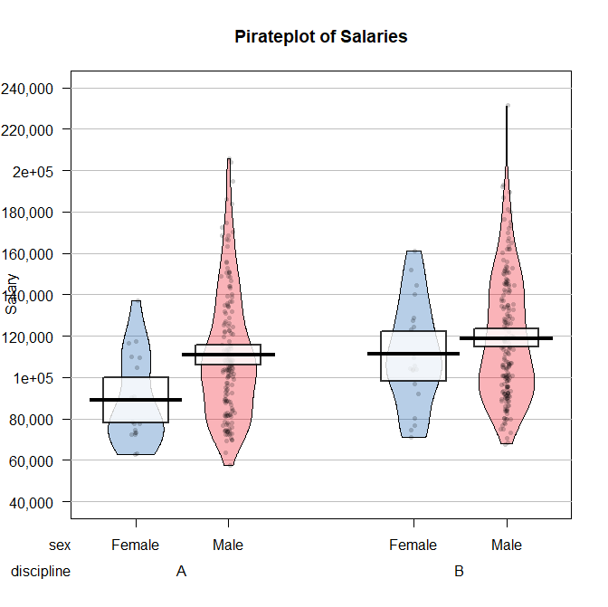
Several things can be seen from the pirate plot. First, there are substantially more male observations than female observations (note the greater number of male dots and the narrower CI for the male means. The data for all the subpopulations seems to be skewed to the right, especially for the male data sets. For each discipline, male salaries appear greater than female salaries, significantly so for the Theoretical discipline (A). For males, the mean salaries appear similar for the two disciplines, but for females, the mean salaries appear higher for the applied discipline (B) than the theoretical.
(b)
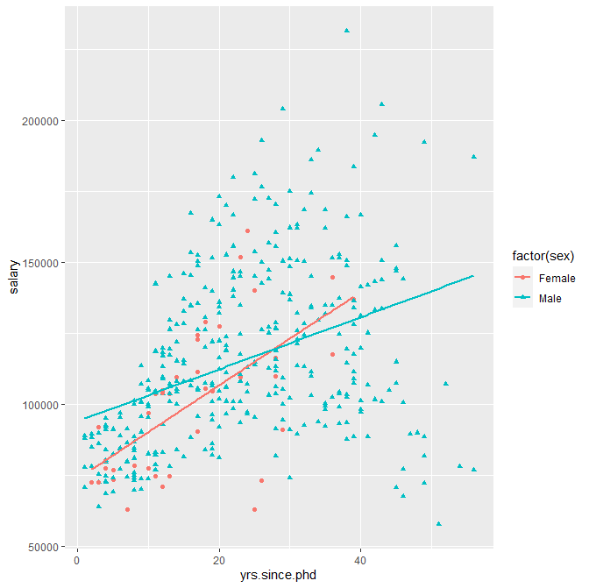
There is a moderate/weak positive association between salary and Years since PhD. The relationship between these two variables is similar for the two sexes; in fact, the association is a bit stronger for females. This may be because of the cluster of males in the bottom right who got their PhDs long ago but still have low salaries.
(c)
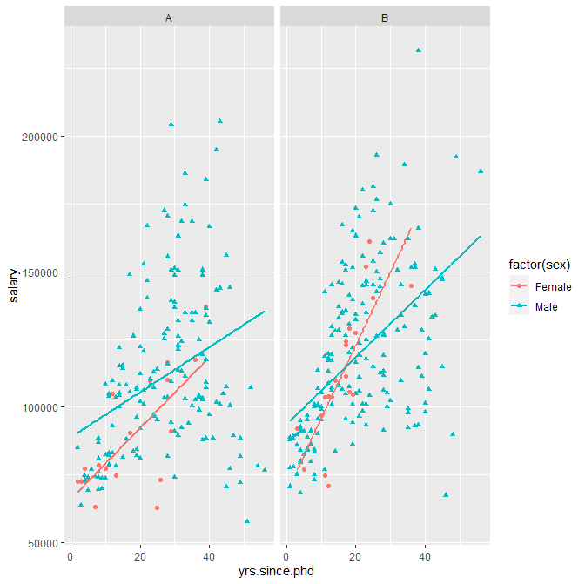
Separating by discipline, we still see the positive association between Salary and years since PhD. One notable thing is that the relationship is sharply positive for females in the applied discipline (B).
7. (a) The three variables are median income (horizontal axis), percent leaving occupation (vertical axis), and number of workers (bubble size).
(b) There is a moderately strong negative association (maybe not linear, though) between percent leaving occupation and median income: It seems that fewer people left the higher-paying occupations. I don’t see number of workers being especially related to the other two variables; the bubble sizes are fairly randomly distributed around the plot.
(c) The two occupations with the most people leaving in 2020 were recreation/fitness workers and athletes/coaches/umpires. This could be because recreational sports leagues and gyms shut down during 2020 due to the pandemic.
(d) Possible answers: (1) Nonlinear relationship between Y and X; (2) addressing high-leverage/influential points; (3) Possible nonconstant error variance.

