STAT 542
Homework 2 Example Solutions

Problem 1, Chapter 2: One option would be to use different colors: Perhaps use blue marks for cars with automatic and red marks for cars with manual. Perhaps a better option is to use differently-shaped plotting symbols, such as to use circular marks for cars with automatic and square marks for cars with manual.

Problem 5, Chapter 2: Answers will vary, but some possible comments are:
(a) The top graph shows the tax rates paid by the various income classes in the U.S. The story told is that in the 1960s, the upper/rich classes paid a large amount of their income in taxes, while the lower classes paid a much lower percentage of their income (it was what is called a progressive tax system). In recent decades (especially since Reagan’s presidency in the 1980s), the wealthier classes have paid much lower tax rates, and the percentages of income that the various classes pay is, while still different, much more similar than in decades past. The second graph shows the amount of various types of tax breaks that the different income classes receive. The story is that the wealthier classes receive more tax breaks than the lower-income classes for most types of tax breaks (the exception being refundable credits, which are mainly used by lower-income taxpayers).
(b) Many possible answers. The first graph, which shows line plots, uses cues like color and slope/direction. The axes seem well-labeled and there is a lot of extra textual information on the graphic. The second graph, a version of a bar chart, uses color, length (and width of bars), and area; it also has lots of labels and text information (it’s arguably overly cluttered in places).
(c) Many possible answers. One possible answer is that the second graph has one variable represented by height of bars and another variable represented by width of bars, but it’s the AREA of the bars that most catches the eye. However, the product of those two variables could be meaningful here.

Problem 1, Chapter 3 Exercises:
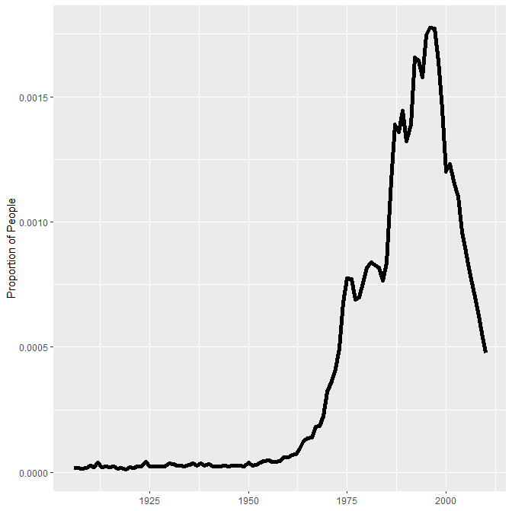
We see the name Angelica had a rise in popularity starting around the 1970s, and it reached its greatest popularity in the 1990s.

Problem 2, Chapter 3 Exercises:

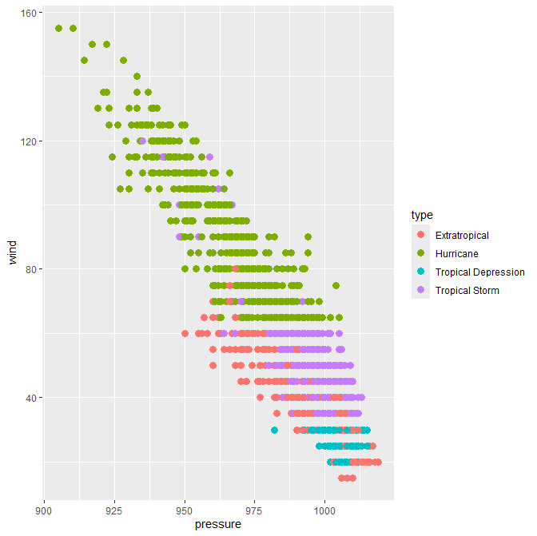

Problem 3, Chapter 3 Exercises:

(a) Answers will vary here. Here are two examples:
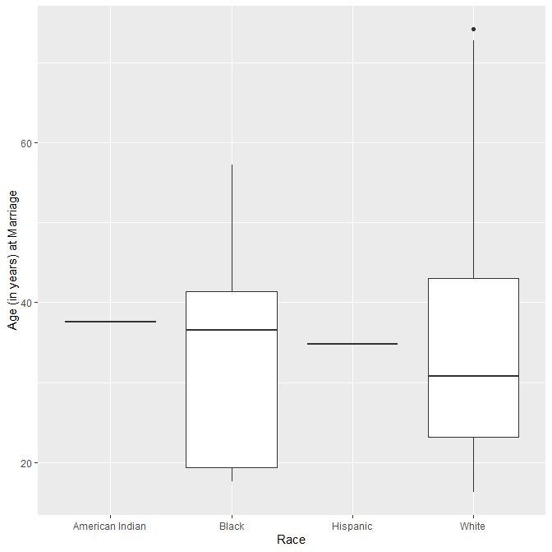

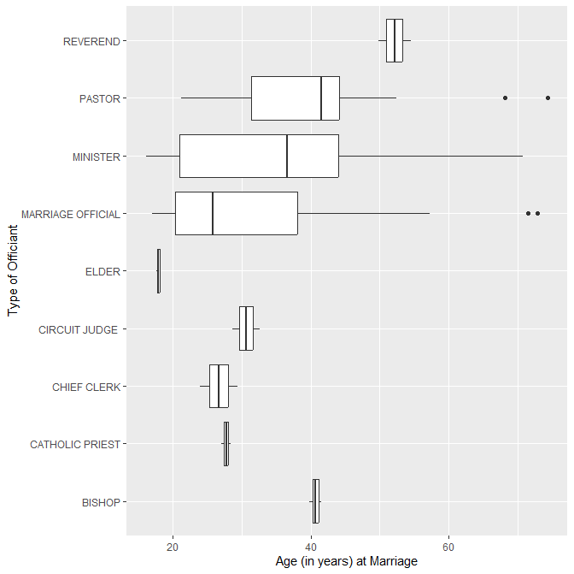
(b) Answer will depend on your graphic in (a).

(c) Answer will vary, but information about 5 variables should be shown in the plot. Here’s one example, with visual cues related to date of birth (x-axis position), age (y-axis position), previous marriages (bubble size), official title (color), and race (facets). Obviously this isn’t the most informative plot!

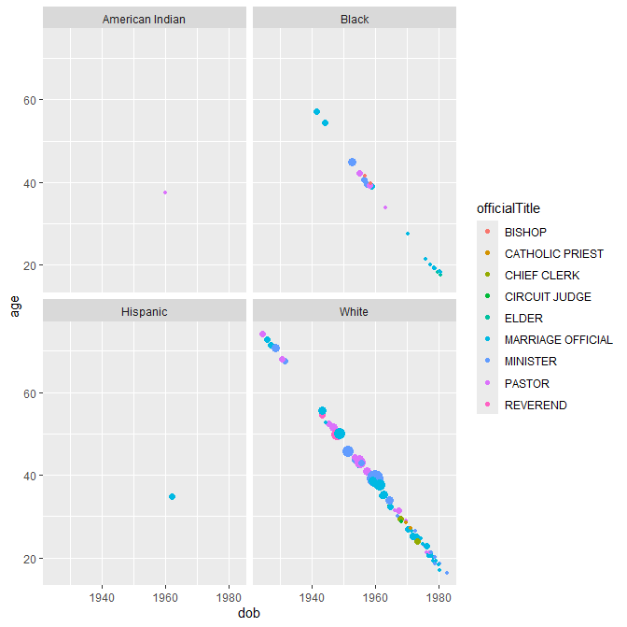

Problem 7, Chapter 3 Exercises:

Part (a):
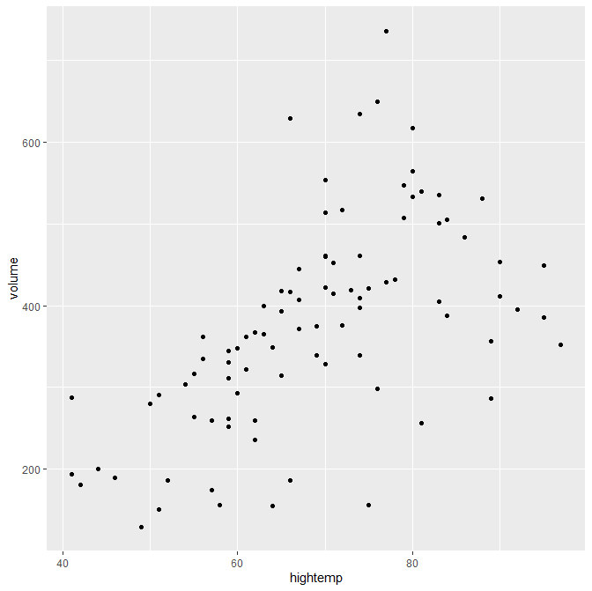
Part (b):

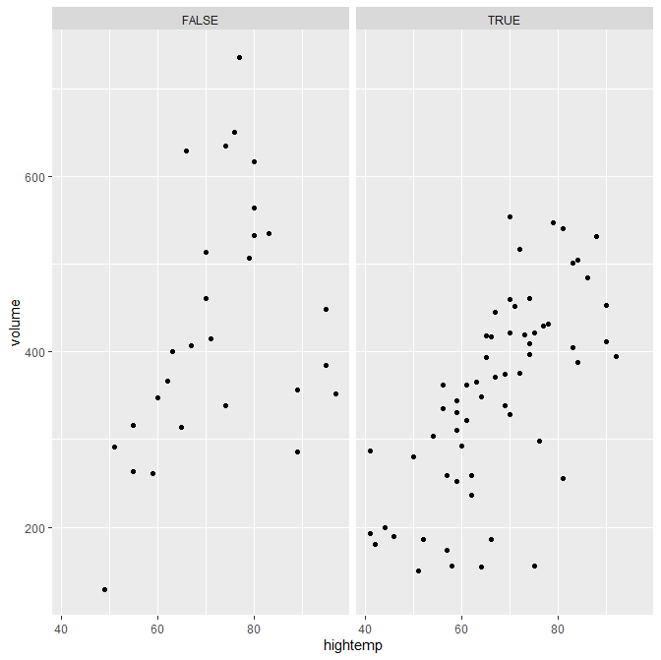
Part (c):

