STAT 110: Introduction to Descriptive Statistics
Course Materials Ordering Information

Your section of STAT 110 requires the purchase of a textbook, access to StatsPortal for the textbook, and an I-clicker.
There are two options for purchasing your course materials:
OPTION 1
Purchase these items at your favorite retail bookstore (Addam’s University Bookstore, SC Bookstore, or the Russell House Bookstore all have these items).
You’ll purchase Statistics: Concepts and Controversies (7th Edition) by David S. Moore and William I. Notz, W.H. Freeman and Company, 2010. This textbook is bundled with access to StatsPortal for Statistics: Concepts and Controversies. Stats Portal is an on-line supplement to the text and will house your assignments, course materials, and grades.
You’ll also need to purchase an I-Clicker. Look for a “bundle” that includes the textbook, access to StatsPortal, and the I-Clicker - this bundle may save you money.

OPTION 2
Purchase access to the StatsPortal on-line at http://courses.bfwpub.com/scc7e.php which includes an “e-book” and purchase the I-Clicker at your favorite retail bookstore. This option is more economical since you will have access to the textbook online (for 365 days) and will not have a printed version of the textbook. Purchasing the StatsPortal with the e-book in this way costs $62.95, so that your total expense will be $62.95 plus the price of the I-Clicker.

Detailed instructions for ordering StatsPortal with the e-book are found on the next page. Do not forget to purchase your I-Clicker.

STEP 1 After visiting http://courses.bfwpub.com/scc7e.php, click the PURCHASE link next to Students
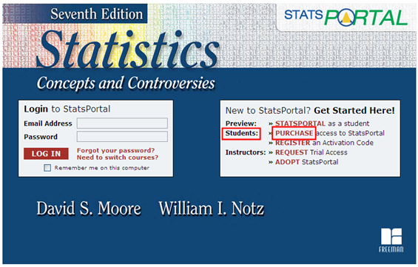

STEP 3 Enter the pertinent information in the “Enter Account Information” pop-up window. Be sure to enter an e-mail address that you check regularly and a name I can match up to my class roll.
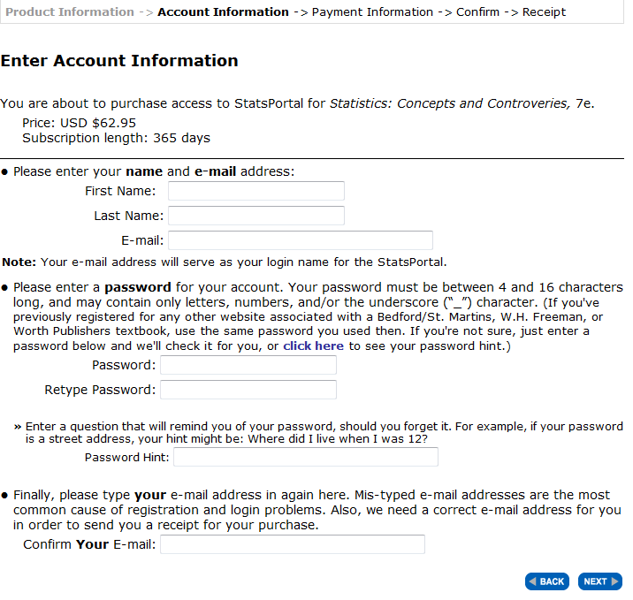

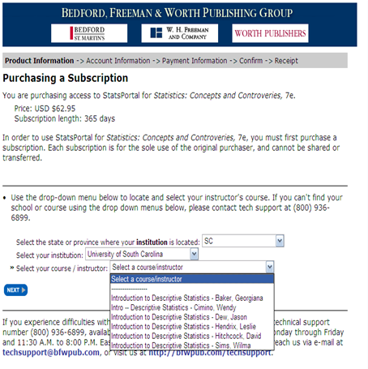
STEP 2 On the pop-up window titled “Purchasing a Subscription”, choose your state, institution, instructor (SC, University of South Carolina, and David Hitchcock) and section from the drop-down menus.

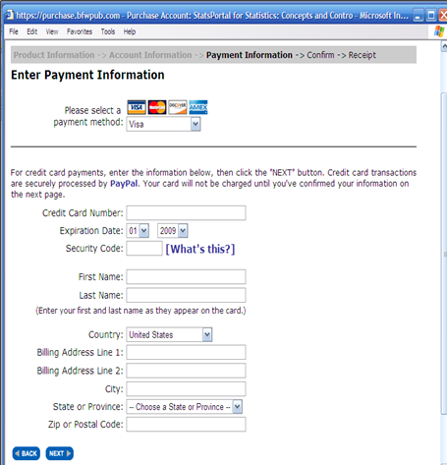
STEP 4 Click “NEXT”. Enter payment information in the boxes in the “Enter Payment Information” pop-up window.

