STAT 530 HW 4B Example solutions

Problem 1: The 2-dimensional MDS solution seems appropriate; its P_{k} value is 0.857, well above the 0.8 threshold. The 2-D solution can be visualized as:
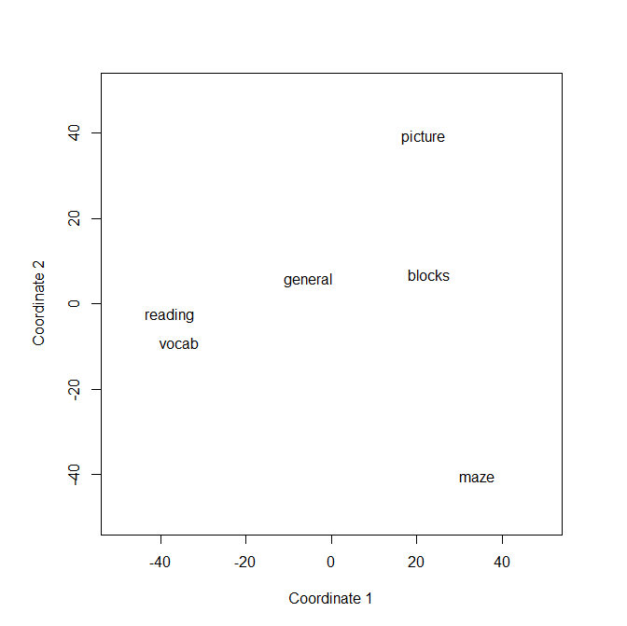

We see that the six tests fall into a few natural groups (maybe 3 groups?). The Reading and Vocabulary tests are clearly similar to each other, which makes sense since both measure “word ability”. The General and Blocks test are similar, and to some extent, the Picture test is near those. The Maze test seems to be something of an outlier.

Problem 2:

> chisq.test(recreation)

Pearson's Chi-squared test

data: recreation
X-squared = 72.768, df = 15, p-value = 1.429e-09

From the chi-square test of association, the low P-value indicates age group and recreational preference are strongly associated, and not independent.
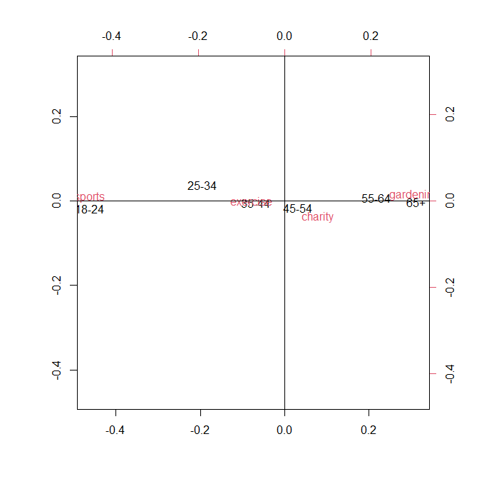
> corresp(recreation,nf=1)

Row scores:
18-24 25-34 35-44 45-54 55-64 65+
-1.7888576 -0.7520073 -0.2613314 0.1212781 0.8416773 1.2073299

Column scores:
exercise sports charity gardening
-0.298404 -1.749793 0.298746 1.163658

From the two-dimensional plot of the correspondence analysis, we see that the 18-24 group prefers sports more often than would be expected if the classifications were independent; the 35-44 age group prefers exercise; the 45-54 age group prefers charity; and the 55-64 and 65+ age groups prefer gardening more often than would be expected if the classifications were independent.

From the one-dimensional correspondence analysis, we see that the 18-24 group tends to prefer sports more often than would be expected under independence (and gardening less often). And both the 55-64 and 65+ age groups tends to prefer gardening more often than would be expected (and sports less often).

