STAT 530 HW 5 Example solutions

Problem 1: Answers may vary according to which hierarchical method and which partitioning method you choose. Below is the dendrogram for a complete linkage solution (note that I have scaled the data before doing the clustering … that does make a difference):

The choice of the number of clusters is subjective. I might choose k=3 clusters. If so, here are the partitions of the racquets into clusters:
[[1]]
[1] "Asics109" "DonnayProOne" "GammaRZR98"
[4] "GammaRZR98T" "HeadPrestigeMid" "HeadPrestigeMidplus"
[7] "HeadPrestigePro" "HeadPrestigeS" "HeadRadicalMidplus"
[10] "HeadRadicalOversize" "HeadRadicalPro" "PrinceRebel95"
[13] "PrinceRebel98" "PrinceWarrior100" "WilsonJuice100"
[16] "WilsonJuice108" "WilsonSteam100" "YonexEZone98"
[19] "YonexEZone100"

[[2]]
[1] "Asics116" "Asics125" "BabolatPureDrive"
[4] "BabolatPureDrive107" "DunlopBiomimetic700" "VolklOrganixV1Midplus"
[7] "VolklOrganixV1Oversize" "YonexEZone107"

[[3]]
[1] "BabolatPureDriveLite" "HeadRadicalS"
[3] "SolincoTour8" "WilsonProStaffSix.One100"

To get an idea of the nature of the clusters, I do a PCA and plot the data in the space of the first 2 PC scores, separated by cluster. The first PC seems to measure the headsize, lightness, and head-heavy balance of the racquets. The second PC measures how light the racquet FEELS to swing.
Loadings:
Comp.1 Comp.2 Comp.3 Comp.4 Comp.5 Comp.6
length 0.376 -0.293 0.720 0.202 0.462
static.weight -0.473 -0.247 0.258 0.800
balance -0.433 0.178 0.410 0.530 -0.373 -0.439
swingweight -0.289 -0.857 -0.110 -0.186 -0.367
headsize 0.453 -0.197 0.235 -0.164 -0.802 0.176
beamwidth 0.399 -0.220 -0.491 0.742

Looking at the plot, the red cluster seems to consist of racquets with large headsize, light weight, and head-heavy balance. The green cluster seems to consist of racquets with smaller headsize, heavier weight, and head-light balance. The blue clusters is racquets that are medium in these respects. The swingweight does not play a major role in the clustering structure, at least in this solution.

For the partitioning method, I do a K-medoids clustering. The highest average silhouette width is actually given by k=2:
my.k.choices avg.sil.width
[1,] 2 0.3674779
[2,] 3 0.2789764
[3,] 4 0.2527459
[4,] 5 0.2757299
[5,] 6 0.2573460
[6,] 7 0.2568995
[7,] 8 0.2484069

The clusters (plotted in the space of the first 2 PCs again) appear similar as before, but without the middle group: The blue cluster seems to consist of racquets with large headsize, light weight, and head-heavy balance. The red cluster seems to consist of racquets with smaller headsize, heavier weight, and head-light balance.

PROBLEM 2:
---------------

It’s best to verify that the data seem approximately multivariate normal before doing a model-based clustering. Looking at a chi-square plot, we see the data seem roughly multivariate normal:

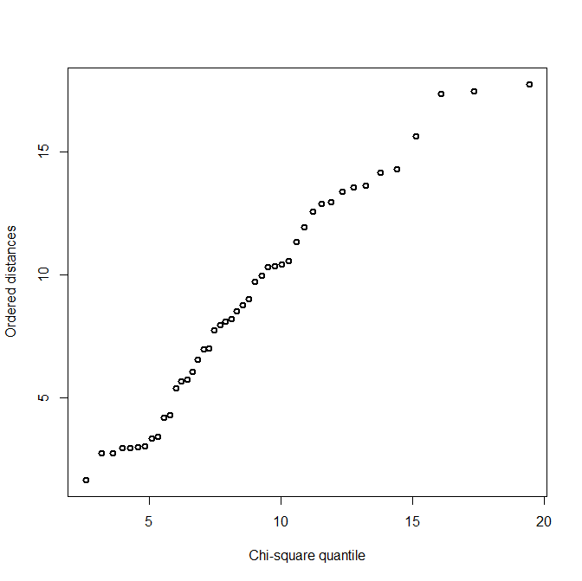

In the model-based clustering, the best solution according to BIC is the 3-cluster solution with the VVI structure. The clustering partition for this is:
[[1]]
[1] 1 2 3 4 5 6 7 8 9 10 12 13 14 15 16 17 18 19 20 21

[[2]]
[1] 11 22 23 24 25 26 27 28 29 30 31 32 33 34 35

[[3]]
[1] 36 37 38 39 41 42 43 44 45 46

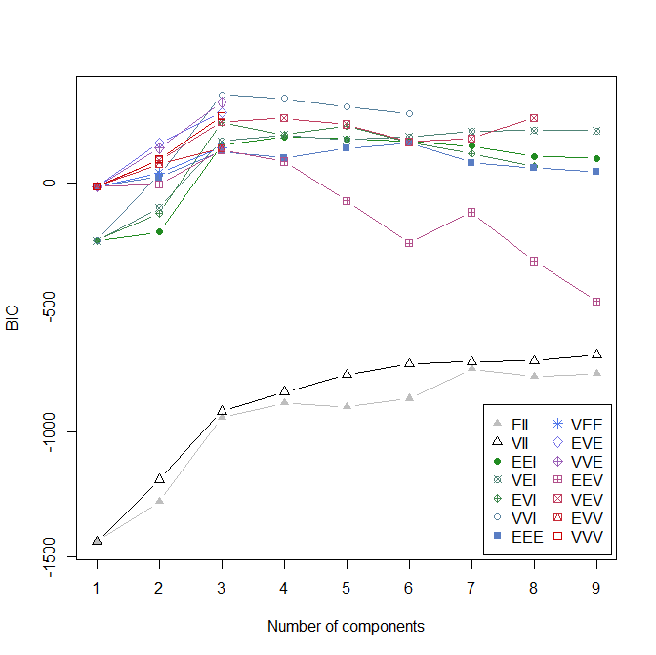
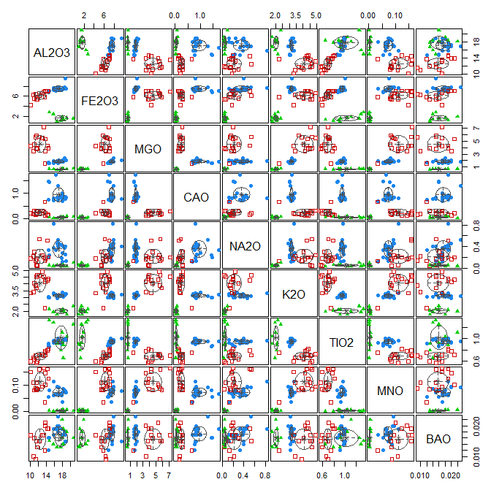
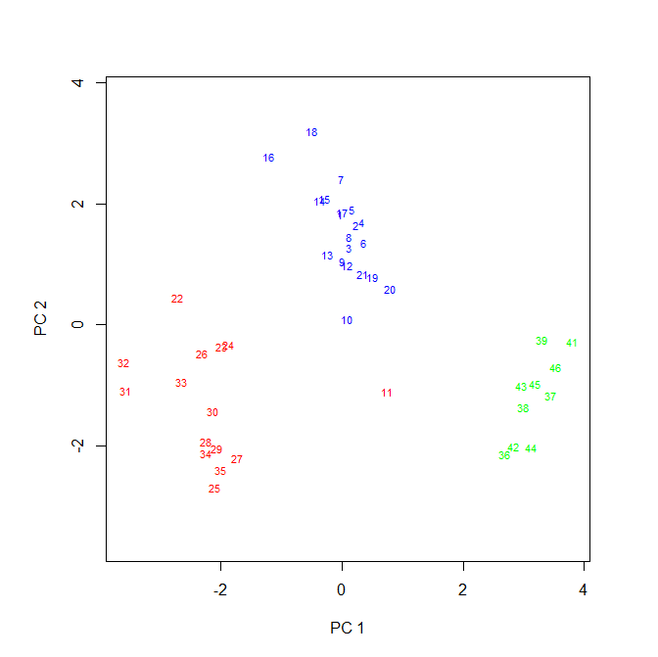
The data seem to be very well separated in the space of the first 2 PCs, which explain about 74% of the data’s variance.

The green cluster has high scores on PC1 (i.e., low MGO, K2O, and MNO). The red cluster has low scores on PC1 (i.e., high MGO, K2O, and MNO). The blue cluster is somewhere in the middle. We can also see these things on the scale of the original variables by looking at the scatterplot matrix above. We note that Pot 11 seems to be in a boundary area between the three clusters, at least when shown in the space of the first two PCs.

One interesting thing:

> rbind(clus.vec,Kiln)
[,1] [,2] [,3] [,4] [,5] [,6] [,7] [,8] [,9] [,10] [,11] [,12] [,13] [,14] [,15] [,16] [,17] [,18] [,19] [,20] [,21] [,22]
clus.vec 1 1 1 1 1 1 1 1 1 1 2 1 1 1 1 1 1 1 1 1 1 2
Kiln 1 1 1 1 1 1 1 1 1 1 1 1 1 1 1 1 1 1 1 1 1 2
[,23] [,24] [,25] [,26] [,27] [,28] [,29] [,30] [,31] [,32] [,33] [,34] [,35] [,36] [,37] [,38] [,39] [,40] [,41] [,42]
clus.vec 2 2 2 2 2 2 2 2 2 2 2 2 2 3 3 3 3 3 3 3
Kiln 2 2 2 2 2 2 2 2 2 2 2 3 3 4 4 4 4 4 5 5
[,43] [,44] [,45]
clus.vec 3 3 3
Kiln 5 5 5

Cluster 1 tends to be the pots from Kiln 1; Cluster 2 tends to be the pots from Kilns 2 and 3; and Cluster 3 tends to be the pots from Kilns 4 and 5.

