Example Solutions HW 6 – STAT 530 – Fall 2024

PROBLEM 1:
---------------

Use linear discriminant analysis (LDA) to build a classification rule to classifying the Bumpus bird data into two groups ("survived" and "died") based on the 5 numerical measurements. Assume equal prior probabilities
of surviving and dying.

(a) Use the LDA rule to predict the survival status for a hypothetical bird with:
tot.length=156, alar.length=242, beak.head.length=31.4, humerus.length=18.1, keel.stern.length=19.4
For part (a), assume equal prior probabilities of surviving and dying.
Give the probability of surviving for such a bird.

For the bird with total length=156, alar length=242, beak-head length=31.4, humerus length=18.1, and keel-stern length=19.4, this bird is predicted to die. The posterior probability that the bird survives is 0.466, given equal prior probabilities of surviving and dying.

(b) Find the plug-in misclassification rate and the cross-validation misclassification rate for the LDA classification rule from part (a).

The plug-in misclassification rate for LDA here is 17/49 = 0.347. The CV rate is 0.551.

(c) Use the LDA rule to predict the survival status for a hypothetical bird with:
tot.length=156, alar.length=242, beak.head.length=31.4, humerus.length=18.1, keel.stern.length=19.4
For part (c), use the default prior probabilities which equal the sample proportions of birds surviving and dying. Give the probability of surviving for such a bird.

For the bird with total length=156, alar length=242, beak-head length=31.4, humerus length=18.1, and keel-stern length=19.4, this bird is predicted to die. The posterior probability that the bird survives is 0.396, using the default prior probabilities of surviving and dying.

(d) Find the plug-in misclassification rate and the cross-validation misclassification rate
for the LDA classification rule from part (c). How do these compare to the rates that you found in part (b)?

The plug-in misclassification rate for LDA here is 18/49 = 0.367. The CV rate is 0.469. The plug-in rate is slightly higher than the one for LDA with equal prior probabilities. But the CV rate for the LDA with the default priors is substantially LOWER than for the LDA with equal prior probabilities.

PROBLEM 2:
---------------

(a) Use the CLASSIFICATION TREE approach on the Egyptian Skulls data in the Chapter 7 in-class R examples
to obtain the classification tree (show the plot of the tree) and classify into an Epoch the new skull
with the measurements:
MB = 133.0, BH = 130.0, BL = 95.0, NH = 50.0
You may assume equal prior probabilities of being in each category.
The classification tree for these data is given below. (The plug-in misclassification rate is 0.487.) We predict the epoch of a new skull with
MB = 133, BH = 130, BL = 95, NH = 50 (assuming equal prior probabilities of being in each category):

c1850BC c200BC c3300BC c4000BC cAD150
1 0.2307692 0.1538462 0.3846154 0.1538462 0.07692308

The predicted category for this skull is c3300BC. We can see this graphically by proceeding down the branches of the tree, based on the logical conditions, until we reach the c3300BC node near the bottom right of the tree.

(b) Use the random forest approach to do the same classification as in part (a). Comment on any similarities and/or differences between your conclusions in part (a) and in part (b). What does the random forest approach tell you about the relative importance of the four various predictors in the classification?

The random forest classifies such a skull as c1850BC. This is DIFFERENT from the classification that the tree made, which was c3300BC. However, c3300BC was the second-most likely epoch, according to the random forest.

The probabilities for each epoch are:
c1850BC c200BC c3300BC c4000BC cAD150
1 0.368 0.2 0.258 0.06 0.114

The random forest says the most important (barely) predictor was Basialiveolar Length (BL); the least important
was Nasal Height (NH).

> skull.rf.eq$importance
MeanDecreaseGini
MB 30.33273
BH 30.42249
BL 31.66626
NH 25.68385

(c) Use this code (PUTTING IN A VALUE for k) to do the same classification as in part (a), using the K-nearest neighbors approach.

Use k=3, k=5, and k=9. Explain how (if at all) your classification results change for the different values of K.

> knn.pred = knn(train = skulls[,-1], test = newobs, cl = skulls[,1], k=3)
> print(knn.pred)
[1] cAD150
> knn.pred = knn(train = skulls[,-1], test = newobs, cl = skulls[,1], k=5)
> print(knn.pred)
[1] c3300BC
> knn.pred = knn(train = skulls[,-1], test = newobs, cl = skulls[,1], k=9)
> print(knn.pred)
[1] c3300BC

For k=3, the predicted epoch was cAD150, but for k=5 and k=9, the predicted epoch was c3300BC (which was the same choice as with the tree).

PROBLEM 3:
---------------

(a) Use a regression tree approach with SO2 as the dependent (response) variable and the other variables as independent (explanatory) variables. (Use can use the default settings of the 'rpart' function.)
Show the plot of the tree. Based on the tree, which seems to be the most important explanatory variables to predict sulphur dioxide content?
Use the regression tree to predict the SO2 for a city with
Temp=60, Manuf=390, Pop=500, Wind=8.5, Precip=45, Days=110

The plot of the tree is shown below. Clearly only temperature and manufacturing play a role in the regression tree. The predicted SO2 for such a city is 15.25.
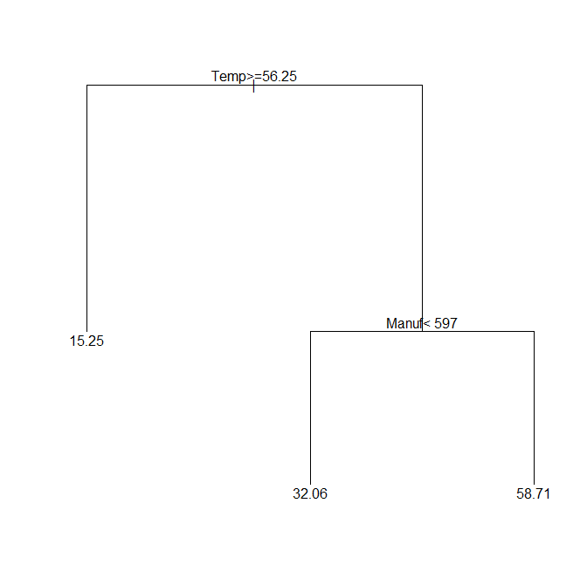

(b) Use the random forest approach to do the same prediction as in part (a). Comment on any similarities
and/or differences between your conclusions in part (a) and in part (b). What does the random forest approach
tell you about the relative importance of the six various predictors in the prediction?

The random forest predicts an SO2 value for such a city as 22.92, quite a bit more than the prediction for the regression tree. The most important predictors according to the random forest are: Manufacturing, Temperature, and Population:

usairpol.rf$importance
IncNodePurity
Temp 4497.509
Manuf 5130.250
Pop 3675.940
Wind 1559.642
Precip 1902.647
Days 2877.352

(c) Use the K-nearest neighbors regression to do the same prediction as in part (a).
Try a variety of values of K, such as 3, 5, and 10; and report how the predicted sulphur dioxide value changes.
For each choice of K, provide a plot of Y-hat values vs. Y values and use these to comment of what your favored choice of K might be.
Comment on any similarities and/or differences between your conclusions in parts (a), (b), and (c).
I got a predicted sulfur dioxide of 33 when k=3, of 27.8 when k=5, and of 23.3 when k=10. The value of 23.3 is close to my predicted value with the random forest. The value of 15.25 from the tree seems unusually low, perhaps because the tree produced by the default settings was excessively simple. Based on the plots of predicted vs. actual Y-values, not of the fits are great, and there are a number of high Y-values that the KNN regression doesn’t come close to predicting correctly. However, the Y-values on the lower range of sulphur dioxide levels are fit pretty well.

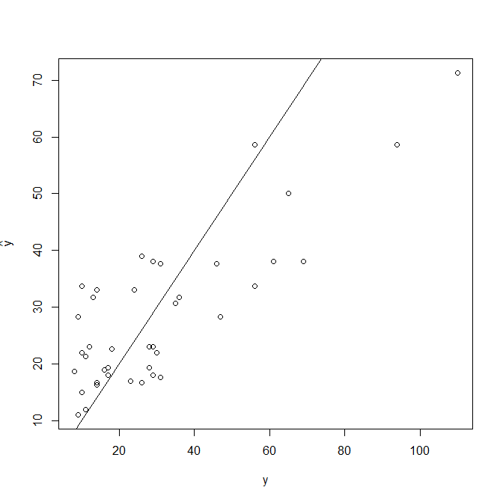
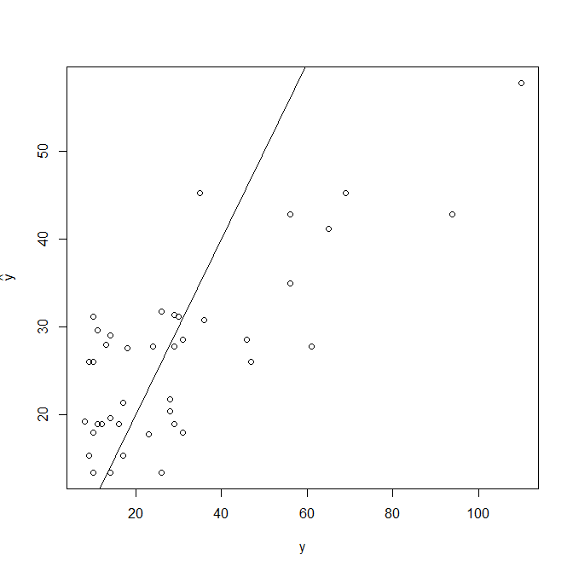
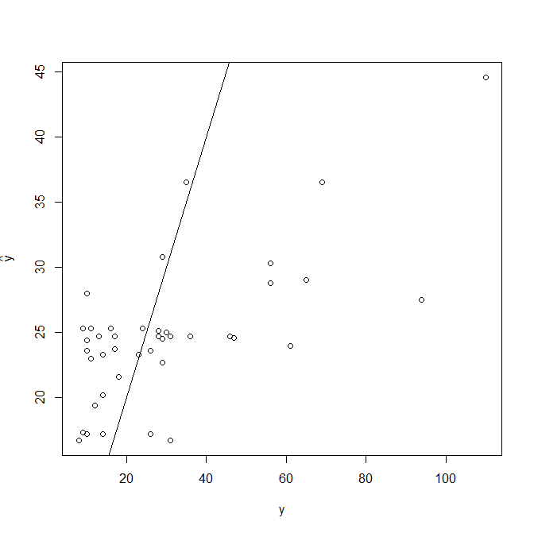

PROBLEM 4 (extra credit):
---------------

Use the Support Vector Machine approach to classify a new baby with
HR = 100, BW = 3000, Factor68 = 0.3, Gesage = 40
as into either the healthy group or the SIDS group.

Comment on any choices of tuning parameters, settings, etc. that you used.

I used cost=0.001 and gamma=5 based on the output from the ‘tune’ function. I used a radial kernel as well. For such a baby, the SVM gives probability 0.732 of being in Group 1 (healthy) and probability 0.268 of being in Group 2 (SIDS). So it classifies the baby as healthy.

