1. Suppose Z has a standard normal probability distribution

Find the following probabilities: DRAW A PICTURE

* 1. P (Z < 1.42)
  2. P ( -0.30 < Z < 1.63)
  3. P ( 1.22 < Z < 2.31)
  4. P (Z > 1.13)

1. Suppose Z has a standard normal probability distribution
   1. If P ( Z < c) = .8554 Find c.
   2. If P ( -c < Z < c) = .3256 Find c.
   3. If P (Z > c) = .8461 Find c.
   4. If P (Z < c) = .2709 Find c.
2. The amount of time devoted to studying statistics each week by students who achieve a grade of A in the course is a normally distributed random variable with a mean of 7.5 hours and a standard deviation of 2.1 hours.
   1. What proportion of A students study for more than 10 hours per week?
   2. Find the probability than an A student spends between 7 and 9 hours studying.
   3. What proportion of A students spend less than 3 hours studying?
   4. What is the amount of time below which only 5% of all A students spend studying?
3. Which one of the following suggests that the data set is not approximately normal?
   1. A data set with IQR = 752 and *s* = 574

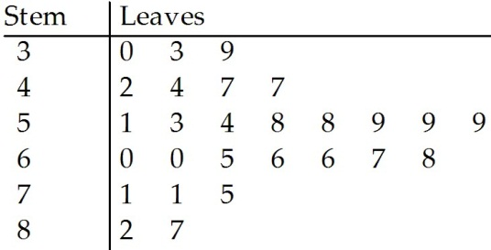



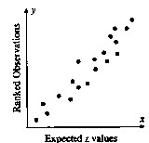

* 1. A data set with 68% of the measurements within .