1. A machine is set to pump cleanser into a process at the rate of 5 gallons per minute. Upon inspection, it is learned that the machine actually pumps cleanser at a rate described by the **uniform distribution** over the interval 4.5 to 8.5 gallons per minute. What is the probability that at the time the machine is checked it is pumping more than 6.5 gallons per minute?
2. The waiting time (in minutes) between ordering and receiving your meal at a certain restaurant is **exponentially** distributed with a mean of 10 minutes. The restaurant has a policy that your meal is free if you have to wait more than 25 minutes after ordering. What is the probability of receiving a free meal?

3. A study conducted by Hershey’s discovered that Americans consumed an average of 11.4 pounds of chocolate per year. Let’s assume that the annual chocolate consumption follows the normal distribution with a standard deviation of 3.6 pounds.

* 1. What is the probability that a randomly selected person will consume
     1. Less than 7 pounds of chocolate next year?
     2. More than 9 pounds of chocolate next year?
     3. Between 8 and 12 pounds of chocolate next year?
     4. Exactly 10 pounds of chocolate next year?
  2. What is the annual consumption of chocolate that represents the 60th percentile?

4. Which one of the following suggests that the data set is not approximately normal?

* 1. A data set with IQR = 752 and *s* = 574

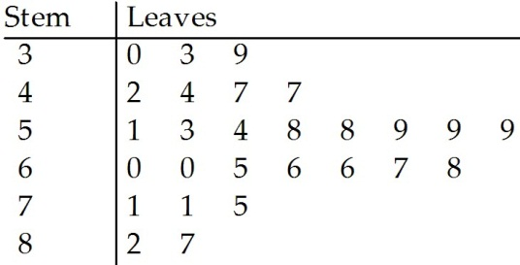



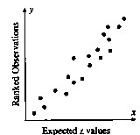

* 1. A data set with 68% of the measurements within .