Chapter 4a: Random Variables and Discrete Probability Distributions

Random variables – a variable that assumes numerical values associated with the random outcomes of an experiment, where one (and only one) numerical value is assigned to each sample point.

Example: Sample Space for tossing 3 coins
{HHH, HHT, HTH, THH, TTH, THT, HTT, TTT}

What if we called the sample space…
{flipping 3 heads, flipping 2 heads, flipping 1 head, flipping 0 heads}?

Is this still a sample space?

Let X = number of heads when tossing 3 coins.
X is then a random variable

Section 4.1 – Two Types of Random Variables

Random variables that can assume a countable number (finite or infinite) of values are called discrete. (Examples – number of light bulbs that burn out, number of hits to a website, number of free-throw attempts before the first shot made)

Random variable that can assume values corresponding to any of the points contained in one or more intervals (infinite and uncountable) are called continuous. (Examples – time it takes to fly from New York City to Los Angeles, The weight of a T-bone steak, amount of rain in Seattle during April)

PART I: DISCRETE RANDOM VARIABLES

Section 4.2 – Probability Distributions for Discrete Random Variables

To completely describe a discrete random variable we need to know the possible values of the discrete random variable and the probability associated with each random variable.

Discrete probability distribution can be described using a graph, table, or formula that specifies the probability associated with each possible value the random variable can assume.

Requirements for the Probability Distribution of a Discrete Random Variable, x

- p(x) ≥ 0 for all values of x
- ∑p(x) = 1

Where the summation of p(x) is over all possible values of x

Discrete Probability Distributions can be described using

Graphs:
Example – The probability histogram that follows represents the number of rooms in rented housing units in 2005.
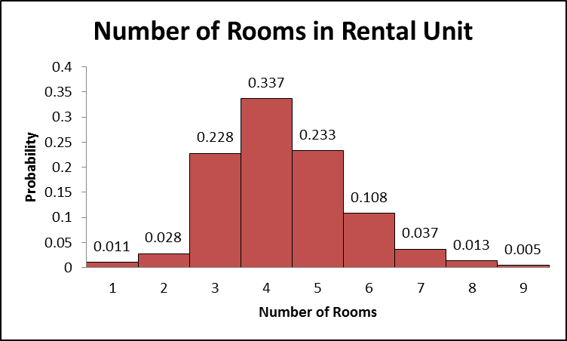
- What is the probability that a randomly selected rental unit has five rooms?

- What is the probability that a randomly selected rental unit has five or six room?

- What is the probability that a randomly selected rental unit has seven or more rooms?

Example – A Wendy’s manager performed a study to determine a probability distribution for the number of people, X, waiting in line during lunch. The results were as follows:

X | P(x)
0 | 0.011
1 | 0.035
2 | 0.089
3 | 0.150
4 | 0.186
5 | 0.172
6 | 0.132
7 | 0.098
8 | 0.063
9 | 0.035
10 | 0.019
11 | 0.002
12 | 0.006
13 | 0.001
14 | 0.001
- What is the probability that eight people are waiting in line for lunch?

- What is the probability that 10 or more people are waiting in line for lunch?

- What is the probability that at least 3 people are waiting in line for lunch?

Formula: We will see several examples of this in the next section

Because the random variable is a variable we can find numerical descriptive measures of these variables (ie, mean, variance, and standard deviation)

Recall how to do a mean when you are given the histogram (we had an example like this in Chapter 2a exercises). We multiplied each value of the variable by its frequency then added them together and divided by the number of total data points we had. This is also true for probability distributions

The mean, or expected value, of a discrete random variable x is

$$μ=E(x)=\sum{x⋅p(x)}$$

Example – From our Rental Unit example – If a rental unit is randomly selected, how many rooms would you expect the unit to have?

Example – From our Wendy’s example – Compute and interpret the mean of the random variable X.

Note: The Expected Value and the mean are interchangeable expression when it comes to random variables. Expected values are not necessarily obtainable value but the average of the long run experiment where the values are weighted by their probabilities.

The variance of a discrete random variable x is

$$σ^{2}=E\left[(x−μ)^{2}\right]=\sum{(x−μ)^{2}p(x)=\left[\sum{x^{2}p(x)}\right]−μ^{2}}$$

The standard deviation of a discrete random variable is equal to the square root of the variance.

Example – From our Rental Unit problem find the variance and the standard deviation.

Note: Now that you know mean and standard deviation you can use these along with Chebyshev’s and Empirical Rule to determine approximate percentages between random variables.

Section 4.3 – Binomial Distribution

The Binomial Distribution is a particular kind of Discrete Random Variable Distribution. It can be represented by a particular formula.

For a Random Variable to be a Binomial Random Variable is has to have ALL of the following 5 characteristics:
Characteristics of a Binomial Experiment
- The experiment consists of n identical trials
- There are only two possible outcomes on each trial. We will denote one outcome by S (for success) and the other by F (for failure).
- The probability of S remains the same from trial to trial. This probability is denoted by p, and the probability of F is denoted by q. Note that q=1-p
- The trials are independent
- The binomial random variable x is the number of S’s in n trials.

Example – In each of the following decide whether or not a binomial distribution is an appropriate distribution of the random variable X, and give your reasons.
- You observe the sex of the next 50 children born at a local hospital; X is the number of girls among them.

- A couple decides to continue to have children until their first girl is born; X is the total number of children the couple has.

- You want to know what percent of married people believe that mothers of young children should not be employed outside the home. You plan to interview 50 people, and for the sake of convenience you decide to interview both the husband and the wife in 25 married couples. The random variable X is the number among the 50 persons interviewed who think mothers should not be employed.

- An auto manufacturer chooses one car from each hour’s production for a detailed quality inspection. One variable recorded is the count X of finish defects (dimples, ripples, etc.) in the car’s paint

- The pool of potential jurors for a murder case contains 100 persons chosen at random from the adult residents of a large city. Each person in the pool is asked whether he or she opposes the death penalty; X is the number who say “Yes”

- Joe buys a ticket in his state’s “Pick 3” lottery game every week; X is the number of times in a year that he wins a prize.
Now that we can identify a Binomial Random Variable, let’s learn how to find the probabilities of these random variables.

Example: A major electronics manufacturer has determined that when one of its televisions is sold, there is 0.08 chance that the set will need service before the warranty period expires. It has also assessed a 0.05 chance that a DVD player will need service prior to the expirations of the warranty.

We are asked:
- Suppose a retailer sells three DVDs on a particular Saturday. What is the probability that at least 2 will need repair prior to the warranty expiring?

How do we find these probabilities – using our previous methods?

P(at least two DVDs needed repair)
= P(two need repair) + P(three need repair)
= 1-[P(none need repair) + P( one needs repair)]

We found this probability by:

Using a tree diagram…

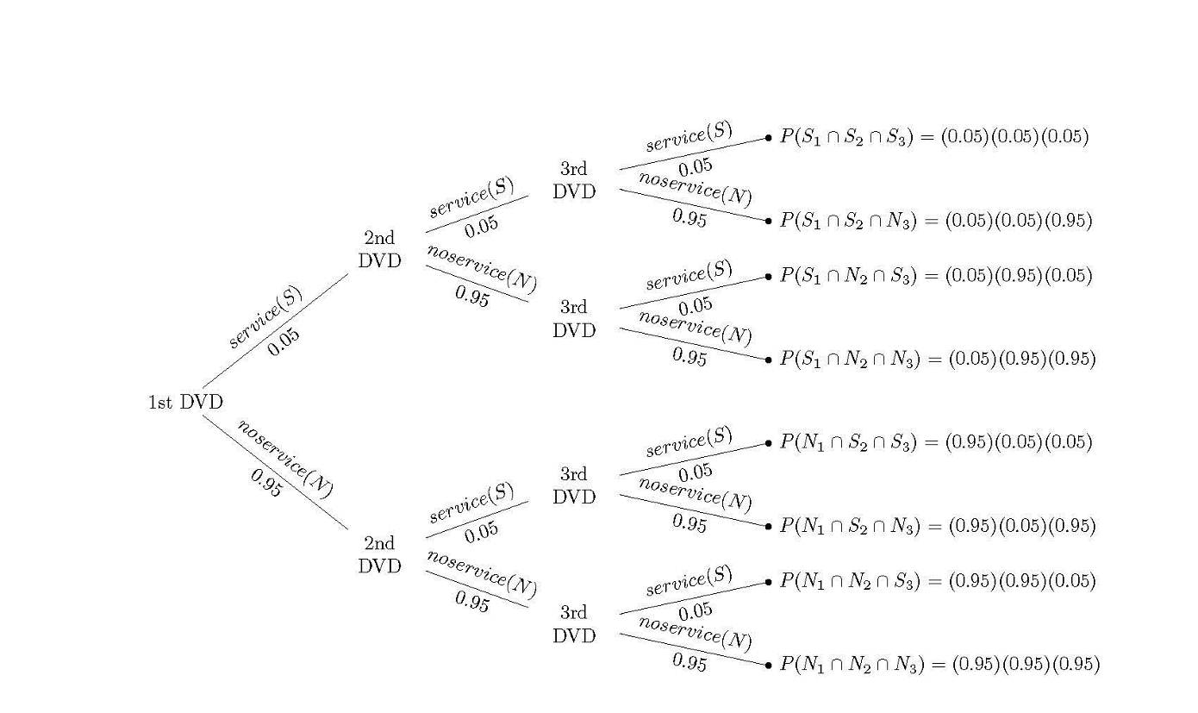

Another way to look at it is…

Again,
P(at least two DVDs needed repair)
= P(two need repair) + P(three need repair) + P(four need repair)
= 1-[P(none need repair) + P( one needs repair)]

$$\begin{aligned}P(\text{at least two need repair})=\left[\left(\begin{matrix}4 \\ 2\end{matrix}\right)\left(\text{.}\text{05}\right)\left(\text{.}\text{05}\right)\left(\text{.}\text{95}\right)\left(\text{.}\text{95}\right)+\left(\begin{matrix}4 \\ 3\end{matrix}\right)\left(\text{.}\text{05}\right)\left(\text{.}\text{05}\right)\left(\text{.}\text{05}\right)\left(\text{.}\text{95}\right)+\left(\begin{matrix}4 \\ 4\end{matrix}\right)\left(\text{.}\text{05}\right)\left(\text{.}\text{05}\right)\left(\text{.}\text{05}\right)\left(\text{.}\text{05}\right)\right] \\ =\left(6\right)\left(\text{.}\text{05}\right)\left(\text{.}\text{05}\right)\left(\text{.}\text{95}\right)\left(\text{.}\text{95}\right)+\left(4\right)\left(\text{.}\text{05}\right)\left(\text{.}\text{05}\right)\left(\text{.}\text{05}\right)\left(\text{.}\text{95}\right)+\left(1\right)\left(\text{.}\text{05}\right)\left(\text{.}\text{05}\right)\left(\text{.}\text{05}\right)\left(\text{.}\text{05}\right)=\text{.}\text{0140} \\ \text{OR} \\ P(\text{at least two need repair})=\text{1-}\left[\left(\begin{matrix}4 \\ 0\end{matrix}\right)\left(\text{.}\text{95}\right)\left(\text{.}\text{95}\right)\left(\text{.}\text{95}\right)\left(\text{.}\text{95}\right)+\left(\begin{matrix}4 \\ 1\end{matrix}\right)\left(\text{.}\text{05}\right)\left(\text{.}\text{95}\right)\left(\text{.}\text{95}\right)\left(\text{.}\text{95}\right)\right] \\ =1−\left[\left(1\right)\left(\text{.}\text{95}\right)\left(\text{.}\text{95}\right)\left(\text{.}\text{95}\right)\left(\text{.}\text{95}\right)+\left(4\right)\left(\text{.}\text{05}\right)\left(\text{.}\text{95}\right)\left(\text{.}\text{95}\right)\left(\text{.}\text{95}\right)\right]=\text{.}\text{0140}\end{aligned}$$

If I represent X as the number of DVDs that need repair, is X a binomial random variable?

- There are 3 identical trials (a trial is each DVD)

- There are only two possible outcomes (S=need repair and F=does not need repair) [S should always be what you are trying to find probability of]

- The probabilities of S remain the same for each trial (p=.05, q=0.95)

- The trials are independent. (each DVD does not affect the other)

- X is the number of DVDs that need repair

This type of random variable has a formula to follow to find the probability of each value of the random variable.

The Binomial Probability Distribution
$$p(x)=\left(\begin{matrix}n \\ x\end{matrix}\right)p^{x}q^{n−x}$$
Where
x=0,1,2,…,n
p=probability of success on a single trial
q = 1-p
n = number of trials
x = number of success in n trials
n-x = number of failures in n trials
$$\left(\begin{matrix}n \\ x\end{matrix}\right)=\frac{n!}{x!(n−x)!}$$

From our DVD formula

Let X = # of DVDs that need repair
n=3 (DVDs)
p=0.05 (probability of needing repair)
What is the probability that at least 2 DVDs (out of 3) need repair?

Let’s do a simple example to see how to use the formula

Example – n=10, p=0.4, x = 3

Now let’s create the entire probability distribution
Example – According to the American Red Cross, 7% of people in the United States have blood type O-negative. A simple random sample of size 4 is obtained, and the number of people X with blood type O-negative is recorded. Construct a probability distribution for the random variable X.

Now let’s find binomial probabilities without finding the entire distribution.

Example – Clarinex-D is a medication whose purpose is to reduce the symptoms associate with a variety of allergies. In clinical trials of Clarinex-D, 5% of the patients in the study experienced insomnia as a side effect. A random sample of 20 Clarinex-D users is obtained, and the number of patients who experienced insomnia is recorded.
- Find the probability that exactly 3 experienced insomnia as a side effect.

- Find the probability that 3 or fewer experiences insomnia as a side effect.

- Find the probability that between 1 and 4 patients, inclusive, experienced insomnia as a side effect.

Because Binomial Random Variables are discrete random variables we can find the mean, variance and standard deviation of them using the same formulas as last section:

Example – Using our O-blood type example find the expected number of people with blood type O-negative out of 4.

X | P(x)
0
1
2
3
4

However, Binomial random variables have a short cut to finding the mean, variance, and standard deviation.

Mean, Variance, and Standard Deviation for a Binomial Random Variable
Mean: $μ=\text{np}$
Variance: $σ^{2}=\text{npq}$
Standard Deviation: $σ=\sqrt{\text{npq}}$

Notice how these equations also give you the answers from the previous examples

Section 4.4 – Other Discrete Distributions: Poisson

Characteristics of Poisson Random Variable
- The experiment consists of counting the number of times a certain event occurs during a given unit of time or in a given area or volume (or weight, distance, or any other unit of measurement)

- The probability that an event occurs in a given unit of time, area, or volume is the same for all the units.

- The number of events that occur in one unit of time, area, or volume is independent of the number that occur in any other mutually exclusive unit.

- The mean (or expected) number of events in each unit is denoted by the Greek letter lambda, λ

The characteristics of Poisson random variable are usually difficult to verify for practical examples. The examples given below satisfy them well enough that the Poisson distribution provides a good model in many instances.

Examples:
- Number of emergency calls in one hour
- Number of hurricanes per year
- Number of people at a drive thru window in one shift
- The amount of toxins in a gallon of city water
- The number of errors in a day shift at a factory

Probability Distribution of Poisson Random Variable

$$p(x)=\frac{λ^{x}e^{−λ}}{x!}$$

Where:
x = 0,1,2,…
λ = mean number of events during given unit of time, are, volume, etc.
e = 2.71828…

Example - According to the Statistical Abstract of the United States, traffic fatalities occur at the rate of 1.5 deaths per 100 million miles. Find the probability that, during the next 100 million vehicle miles, there will be
- Exactly zero deaths.

- At least one death

- More than one death

Mean and Variance for Poisson distribution
Again we could use the formulas for discrete random variables but this is special kind of discrete random variables and has its own shortcut.

Mean: $μ=λ$
Variance: $σ^{2}=λ$

