UNIT 3 Notes: Chapter 6 and 10

Chapter 10: Simple Linear Regression

Chapter 10 introduces inference about a response variable from an explanatory variable. It is possible to perform this same type of analysis with multiple explanatory varibles which you will see in Chapter 11 in MGT 310. Rather than break down this Chapter into sections I will break down the Chapter into steps to perfrom a simple linear regression.

When you have two quantitative variables often you would like to know if how these two variables are related or associated. If you determine that the two quantitative variables are linearly associated it is appropriate to fit a line to the data. Once a line has been fit you can then plug in any value of the explanatory variable to predict what the response variable will be.

For Example: A nation job placement company is interested in developing a model that might be used to explain the variation in starting salaries for college graduates based on the college GPA. The following data were collected through a random sample of the clients with which this company has been associated.
GPA | Starting Salary
3.20 | $35,000
3.40 | $29,500
2.90 | $30,000
3.60 | $36,400
2.80 | $31,500
2.50 | $29,000
3.00 | $33,200
3.60 | $37,600
2.90 | $32,000
3.50 | $36,000

Example: College GPA and high school GPA
Example: Test 3 Score and Test 4 Score
Example: Mother’s heights and daughter’s heights

Understanding Concept:
Assume we have an explanatory variable (x) that is quantitative and a response variable (y) that is also quantitative, such as College GPA (x) and Starting Salary (y).

If you were asked to determine if Starting Salary DEPENDS on College GPA what would a graph look like that showed a definite dependence between the two variables? (Assume linear dependence (relationship))

What would the graph look like if that showed a definite independence between the two variables? (ie it would not matter what College GPA is as to what your starting salary would be) (Again, assume linear relationship)

What would the graph look like if you were unsure whethere there was a linear relationship between College GPA and starting salary? (Again assume linear relationship)

Example: For simplicity purposes we are going to use an example without any units

x | 3 | 1 | 3 | 5
y | 5 | 8 | 6 | 4

Before we begin looking a simple linear regression let’s review from your previous math courses what the equation for a line looks like.

Recall:

Where m is the slope and b is the y-intercept

The concept covered in this Chapter fits a line to data with one response and one explanatory variable, then uses hypothesis testing to determine if the fit line can be used to predict values of the response variable.

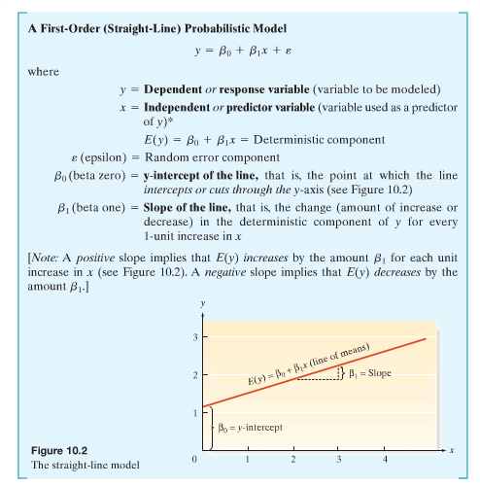

There are several steps to follow when analyzing two quantitative variables to determine if they are linearly associated.

Step 1: Hypothesize the deterministic component of the model that relates the mean E(y), to the independent variable x.

$$E(y)=β_{0}+β_{1}x$$

Step 2: Use the sample data to estimate unknown parameters in the model

- Find the slope (${\hat{β}}_{1}$) from the sample data
- Find the y-intercept (${\hat{β}}_{0}$) from the sample data
- Be able to interpret these values

Note: the “hats” on the parameters means these are values that have been estimated by the sample – similar to the “hat” on sample proportion

Step 3: Specify the probability distribution of the random error term and estimate the standard deviation of this distribution

- Check assumptions of probability distribution of random error ε
- Find value of variability of random error (σ²)
- Be able to interpret this value

Step 4: Statistically evaluate the usefulness of the model

- Hypothesis test of β₁

- Calculate coefficient of correlation (r)
- Interpret coefficient of correlation
- Hypothesis test of ρ
- Calculate coefficient of determination (r²)
- Interpret coefficient of determination

Step 5: When satisfied that the model is useful, use it for prediction, estimation, and other purposes

- Use line for prediction and estimation
- Create confidence intervals for estimation

Now we will look at these steps in detail:
Step 1: Hypothesize the deterministic component of the model that relates the mean E(y), to the independent variable x.

We are considering only straight lines with one explanatory variable therefore the model in this Chapter will always be…

$$E(y)=β_{0}+β_{1}x$$

Step 2: Use the sample data to estimate unknown parameters in the model

- Plot the data to a scattergram (or scatterplot)

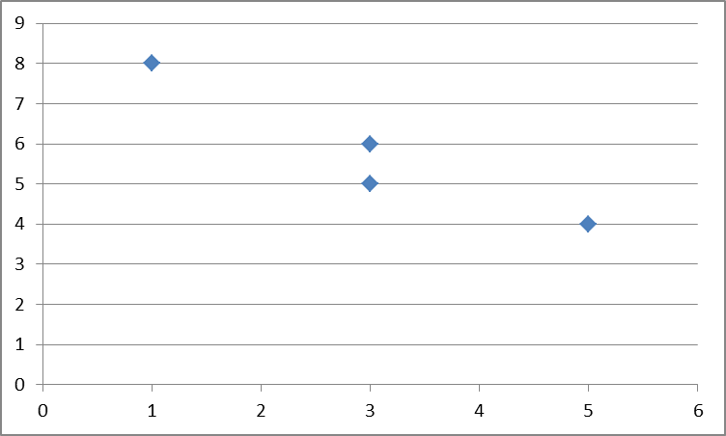

Determine whether fitting a line to the data seems appropriate based on the graph.

Note that if fitting a line is appropriate that not all points will necessarily fall directly on the line. These deviations from the fitted line are known as errors of prediction. When fitting a line to the data the goal should be to minimize the errors – doing so by fitting a line where the sum of the squared errors is minimized. This line is known as the least squares line, the regression line, the least squares predication equation or least squares regression line.
The methodology used to obtain this line is called the method of least squares.

Find the slope (${\hat{β}}_{1}$) from the sample data

x | y | $$x_{i}−\bar{x}$$ | $$y_{i}−\bar{y}$$ | $$\left(x_{i}−\bar{x}\right)\left(y_{i}−\bar{y}\right)$$ | $${\left(x_{i}−\bar{x}\right)}^{2}$$
3 | 5
1 | 8
3 | 6
5 | 4

Find the y-intercept (${\hat{β}}_{0}$) from the sample data

$${\hat{β}}_{0}=\bar{y}−{\hat{β}}_{1}\bar{x}$$

Be able to interpret these values
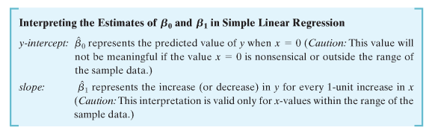
Note: the “hats” on the parameters means these are values that have been estimated by the sample – similar to the “hat” on sample proportion

Step 3: Specify the probability distribution of the random error term and estimate the standard deviation of this distribution

Check assumptions of probability distribution of random error ε (you will learn how to check these in Chapter 11)

Assumption 1: The mean of the probability distribution of ε is 0 – that is, the average of the values of ε over an infinitely long series of experiments is 0 for each setting of the independent variable x. This assumption implies that the mean value of y, E(y), for a given value of x is $E(y)=β_{0}+β_{1}x$.

Assumption 2: The variance of the probability distribution of ε is constant for all setting of the independent variable x. For our straight line model, this assumption means that the variance of ε is equal to a constant, say σ2, for all values of x..

Assumption 3: The probability distribution of ε is normal.
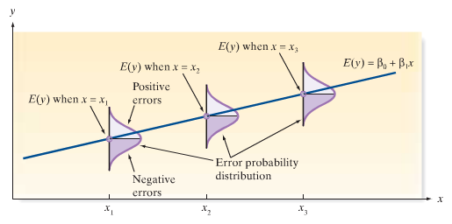

Assumption 4: The values of ε associated with any two observed values of y are independent – that is, the value of ε associated with one value of y has no effect on the values of ε associated with other y values.

Find value of variability of random error (σ²)

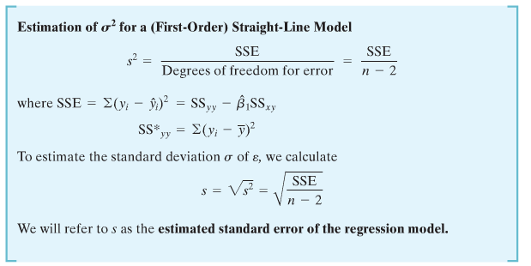

******CAUTION – When performing these calculations, you may be tempted to round the calculated values of SS_{yy}, β₁, SS_{xy}. Be certain to carry at least six significant figures for each of these quntities to avoid substantial errors in calculations of SSE

Example: Find the estimated standard error of the regression model for our example. Let x represent the number of hours per day exposed to cigarette smoke for a been plant and y represent the height (inches) of the plant after 2 weeks.

x | y | $\hat{y}$(value of predicted values of y from equation) | $$y_{i}−{\hat{y}}_{i}$$ | $${\left(y_{i}−{\hat{y}}_{i}\right)}^{2}$$
3 | 5
1 | 8
3 | 6
5 | 4

Be able to interpret this value

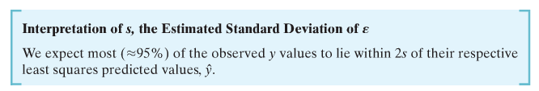

Step 4: Statistically evaluate the usefulness of the model

Hypothesis test of β₁

Hypothesis Test for β₁ (A Test of Model Utility: Simple Linear Regression)

Hypotheses:

One Tailed Test
$$H_{0}:β_{1}=0$$

$$\begin{aligned}H_{a}:β_{1}<0 \text{OR} \\ H_{a}:β_{1}>0\end{aligned}$$

Two-Tailed Test

$$H_{0}:β_{1}=0$$

$$H_{a}:β_{1}≠0$$

Assumptions:

The four assumptions about ε

Testing:

Test Statistic:
$$t=\frac{{\hat{β}}_{1}}{s_{{\hat{β}}_{1}}}=\frac{{\hat{β}}_{1}}{s\sqrt{{\text{SS}}_{\text{xx}}}}$$

Find Rejection Region

One-tailed:
t<-t_{α} when $H_{a}:β_{1}<0$ (or t>t_{α} when $H_{a}:β_{1}>0$)

Two-tailed:
|t| > t_{α/2}

t_{α} and t_{α/2} based on (n-2) degrees of freedom

Or P-value by technology

Conclusions:

If test statistic falls in rejection region OR p-value < α

At the ___% significance level, my test statistic (t = ___) falls in the rejection region (or my p-value (_____) < α) therefore, I reject my null hypothesis. The data provides sufficient evidence to support that the slope of the line is (greater than, less than or different from) 0.

OR

If test statistic does not fall in rejection region OR p-value > α

At the ___% significance level, my test statistic (t = ___) does not fall in the rejection region (or my p-value (______) > α) therefore, I do not reject my null hypothesis. The data provides insufficient evidence to support that the slope of the line is (greater than, less than or different from) 0.

Example – Perform two-tailed Hypothesis test of slope

Calculate coefficient of correlation (r)

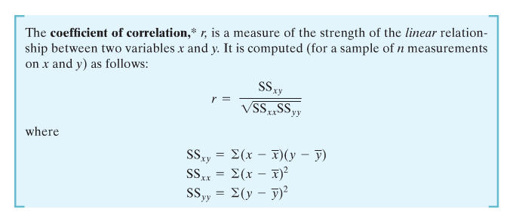

Example:
x | y | $$x_{i}−\bar{x}$$ | $$y_{i}−\bar{y}$$ | $$\left(x_{i}−\bar{x}\right)\left(y_{i}−\bar{y}\right)$$ | $${\left(x_{i}−\bar{x}\right)}^{2}$$
3 | 5
1 | 8
3 | 6
5 | 4

Calculate coefficient of determination (r²)

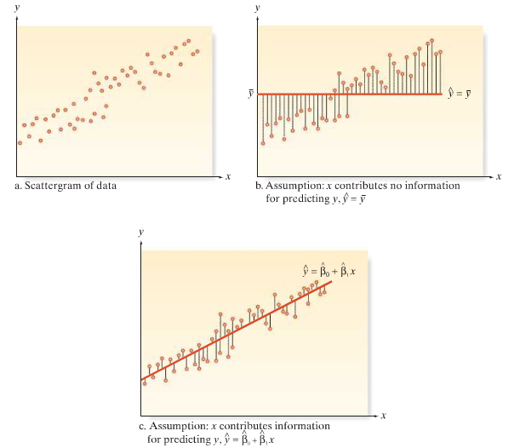
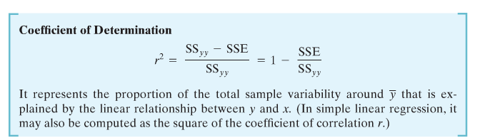

Example -

Interpret coefficient of determination

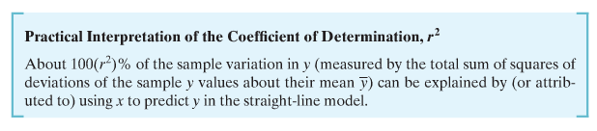

Example –

Step 5: When satisfied that the model is useful, use it for prediction, estimation, and other purposes

Use line for prediction and estimation

Plug in value of x into equation to predict y at that level (Note: it is only appropriate to plug in value that are x-values used in the scope of the problem)

Example – What is the predicted value of y when x is 4

Create confidence intervals for estimation

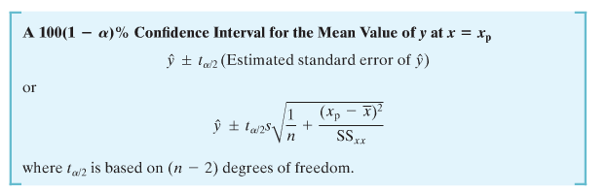

Example – Create a confidence interval for the prediction at x = 4

All of these steps can be done using DDXL
See page 612 in book for flow chart – also available on Blackboard
Do a full example:

Example –Perform all necessary steps to determine if a line fits well to the data, then use the line to predict values at x = 4. Let x represent number of televisions in a household and y represent the number of couches in that household.

X | Y
0 | 1
3 | 2
4 | 6
5 | 9
12 | 12

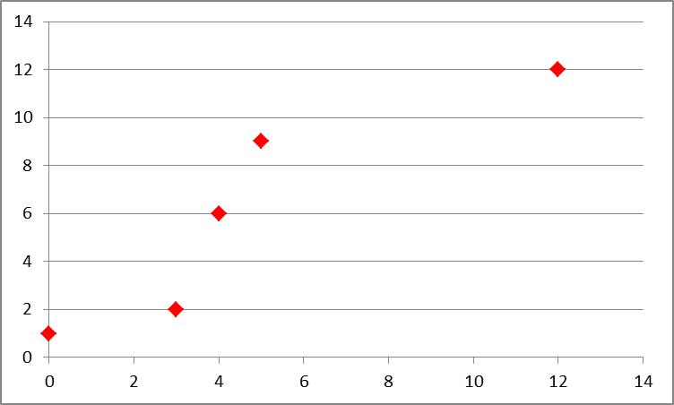

- Find the unknown parameters in the line model (${\hat{β}}_{0}$and${\hat{β}}_{1}$) and interpret the values.
- Find the value of the estimated standard error of regression equation and interpret
- Perform test of slope at alpha = 0.5.
- Calculate and interpret coefficient of correlation and coefficient of determination.
- Use line to predict values at x = 4, create confidence interval for this prediction.
- Use DDXL to check your answers.

