**Worksheet 2 – Chapter 2a**



**Use pages 40 – 41 in the Excel Manual to help with the following problem.**

**Color and clarity of diamonds.** Diamonds are categorized according to the “four C’s”: carats, clarity, color, and cut. Each diamond stone that is sold on the open market is provided a certificate by an independent diamond assessor that lists these characteristics. Data for 308 diamonds were extracted from Singapore’s *Business Times* and are saved in the **DIAMONDS** file. Color is classified as D, E, F, G, H, or I, while clarity is classified as IF, VVS1, VVS2, VS1, or VS2.

1. Create a pie chart and frequency table for COLOR using DDXL. (Attach the pie chart and table to this document)

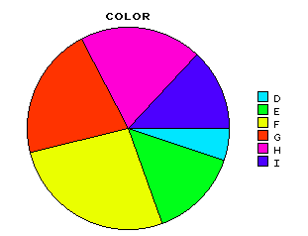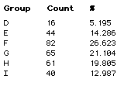

1. Create a pie – chart for clarity using DDXL. (Attach the pie chart and table to this document)

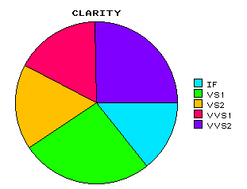 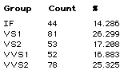

1. What is the color that occurs most often? Least often?

F – most at 26.6%

D – least at 5.2%

1. What is the clarity that occurs most often? Least often?

VS1 – most at 26.3%

IF – least at 14.3%

1. What percentage of the data has either color D or E?

either D or E = 5.195 + 14.286 = 19.481%

1. What percentage of the data has clarity other than IF?

Clarity other than IF = 100 – 14.286 = 85.714%

**Use pages 34 – 39 in the Excel Manual to help with the following problem.**

In addition to color and clarity, the independent certification group (GIA, HRD, or IGI) and the number of carats were recorded for each of 308 diamonds for sale on the open market. Recall that the data are saved in the **DIAMONDS** file.

1. Create a histogram to describe the carat distribution of all 308 diamonds using the default bin width of DDXL. Attach the histogram to this worksheet.

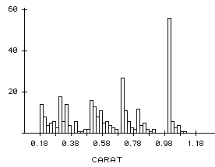

1. Create a histogram to describe the carat distribution of all 308 diamonds using a bin width of 0.1. Attach the histogram to this worksheet. **To change the bin width in DDXL click on the upper left hand corner of the histogram create for part a – choose Plot Scale – enter in the bin width in box for Bin width.**

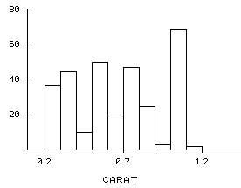

**For parts c and d you will have to create new columns with only the necessary information (i.e., copy and paste the relevant information to new columns in the Excel file)**

1. Use a histogram to describe the carat distribution of diamonds certified by the GIA group using a bin width of 0.1 **(Align bars at .18 – changing alignment can be done in the same location as changing bin width)**. Attach the histogram to this worksheet.

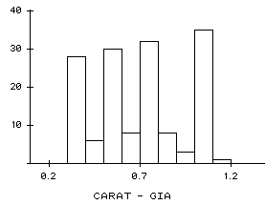

1. Repeat part **b** for the HRD and IGI certification groups. Attach the histograms to this worksheet.

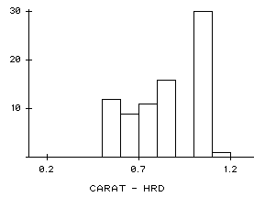 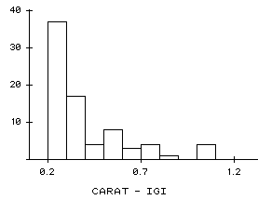

1. Compare (center, shape, and variability) the three cart distributions, parts c and d. Is there one particular certification group that appears to be assessing diamonds with higher carats than the others?

HRD distribution seems to have the largest center followed by GIA and then IGI

All three graphs have different shapes GIA distribution is symmetric, HRD distribution is left skewed and IGI is right skewed

IGI has the largest variability, followed by GIA and then HRD.

HRD seems to be assessing diamonds with higher carats than the others.