**Worksheet 3 – Chapter 2b**

The following data reflect the number of times a sample of business executives flew on business during the previous month:

|  |  |  |
| --- | --- | --- |
|  |  |  |
| 4 |  |  |
| 6 |  |  |
| 9 |  |  |
| 4 |  |  |
| 5 |  |  |
| 7 |  |  |
|  |  |  |

1. By hand – compute the **mean** for these data.
2. By hand – compute the **median** for these data.
3. By hand – compute the **range** for these data.
4. By hand – compute the **variance** for these data.
5. By hand – compute the **standard deviation** for these data.
6. By hand – compute the **quartiles (Q1, Q2, and Q3)** for these data.
7. By hand – compute the **IQR** for these data.
8. By hand – create a **box-plot** for these data. Label axis.

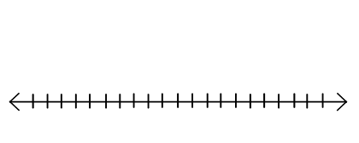

1. Using DDXL:Summaries of One Variable find the values for part (a) – (g). Attach Summary from DDXL.
2. Using DDXL (page 45-46 in Excel Manual) create a box plot for these data. Attach Box-plot from DDXL.