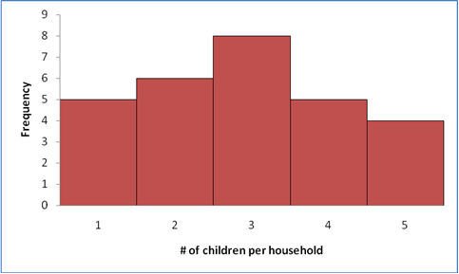

* 1. Calculate the mean. [Think about what the data values are]
  2. What is the mode?
  3. What is the shape of the histogram?
  4. What is the median?
  5. What percentage of the data values are greater than 2?

1. Answer the following using the equations and definitions for mean and median.
   1. Angelique made scores of 85, 56, and 91 on her first three statistic tests. What does she need to make on her next test to have an 80 test average?
   2. Of 500 high school students whose mean height is 67.8 inches, 150 were girls. If the mean height of the girls was 63.0 inches, what is the mean height of the boys?

3. Each year, *Forbes* magazine compiles a list of the 400 richest Americans. For 2005, the top five on the list are as shown in the following table. (Be sure to give units)

|  |  |
| --- | --- |
| **Person** | **Wealth ($ billions)** |
| Bill Gates | 51 |
| Warren Buffett | 40 |
| Paul Allen | 22.5 |
| Michael Dell | 18 |
| Larry Ellison | 17 |

* 1. Calculate the range
  2. Calculate the variance and standard deviation. (show work – 2 decimal places)