Chapter 2a: Methods for Describing Sets of Data

Chapter 2 deals will the descriptive statistics side of statistics. These are the fundamentals/basics and the first steps in analyzing sets of data.

RECALL: Two Types of Variables
- Categorical (Qualitative)
  - Belongs to one of set of categories
  - For example: gender, religious affiliation, place of residence, whether is rained
- Quantitative
  - Take on numerical (measured) values that represent different magnitudes of the variable
  - For example: age, annual income, number of years of education completed
  - NOT area codes or zip codes Why?

Describing Categorical Data
We will first look at how to describe qualitative data. In order to describe this data no averages, or calculations will be done on the variable itself only counts (or calculations on counts) will be taken.

Numerical Summarization for Categorical Data
- Frequency Tables
  - Count how often each category appears in data, this is the categories frequency
  - The category with the highest frequency is the mode
  - The frequency divided by the total number of observations is the proportion
  - The proportion multiplied by 100 is the percentage
  - Both proportions and percentages can be called relative frequencies
  - A listing of possible values and the frequency is a frequency table

Example: What Is Your Favorite Tailgate Game?
- Beer pong
- Flip cup
- Corn hole
- Horseshoes
- Throwing football
- Ladder golf

Frequency Distribution – counts of each categories
Relative Frequency Distribution – the proportion each category occurs

Tailgate Game | Frequency | Relative Frequency
beer pong | 44 | 44/208 = .212
flip cup | 26 | 26/208 = .125
corn hole | 38 | 38/208 = .183
horseshoes | 34 | 34/208 = .163
throw football | 33 | 33/208 = .159
ladder golf | 33 | 33/208 = .159

How Can We Describe Data Using Graphical Summaries?

- Graphs for Categorical Variables
  - Bar chart – vertical bar for each category. The height of the bar is either the frequency or percentage of observations in the category
  - Pie chart – circle having “a slice of pie” for each category. The size of the slice corresponds to the percentage of observations in the category
  - Pareto chart (diagram) – a bar graph with categories ordered by frequency, from the tallest bar to shortest bar

Bar Chart

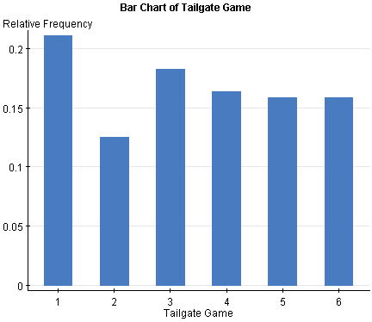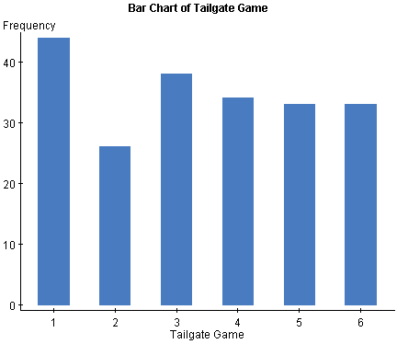

Pie Chart

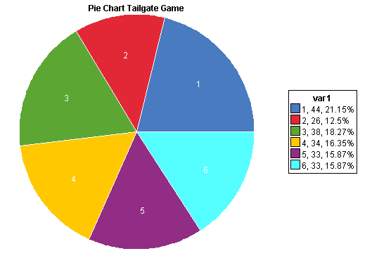
Using DDXL To Create Graphs
- Sometimes datasets are too large (or the technique is too difficult) to do things by hand.
- We can use DDXL to create these types of graphs.
Excel Manual:
- Bar Chart – p 32-34
- Pie Chart – p 40-41

****More important than creating the graphs is interpreting (or understanding) what the graph is describing about the data

Example – Tailgate Game Interpretation
- What is the most popular tailgate game in this sample?

- How many people chose beer pong?

- What percentage of the sample like either beer pong or horseshoes?

- How many more people voted for ladder golf over flip cup?

- Which game was found to be the least favorite of the games?

- What was the frequency of the least favorite game?

Describing Quantitative Data

When your data is quantitative we use some of the same descriptive measures as qualitative data as well as some new descriptive measures that are useful calculations for summarizing data.

Just like qualitative data you can create frequency and relative frequency tables

How Can We Describe Data Using Graphical Summaries?
- Graphs for Quantitative Variables
  - Dot Plot – a dot for each observation is placed just above the value on the number line (shows all observations)
  - Stem and leaf plot – leaves are far right digit, stem all other digits (shows all observations)
  - Histogram – uses bars to portray the frequencies or the relative frequencies of the possible outcomes of a quantitative variable

Example – Regis Auto Rental – The operations manager for Regis Auto Rental is interested in performing an analysis of the miles driven for the cars the company rents on weekends. The following data represent the miles driven in the cars:

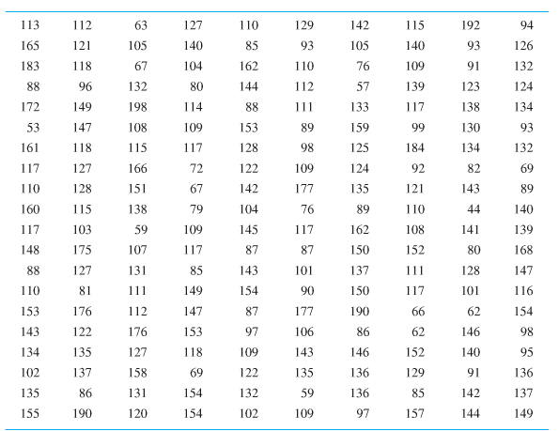

Dot Plot

Dot plots are best for smaller (sample of approx. 300 or less) datasests
- Draw a horizontal line, Label it with the name of the variable, and mark regular values of the variable on it
- For each observation, place a dot above its value on the number line.

Example – Regis Auto Rental

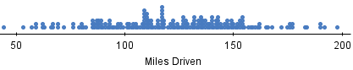

Stem and Leaf

Stem and Leaf Plots are also best for smaller datasets
- Sort the data in order from smallest to largest
- Stems in one column, starting with smallest.
- Place a vertical line to their right
- On the right side of vertical line, indicate each leaf (final digit) that has a particular stem. List leaves in increasing order

Example – Regis Auto Rental

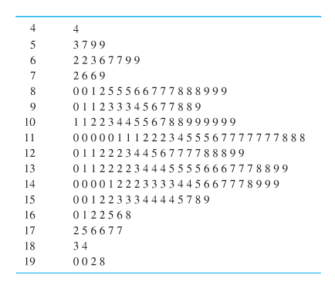

The stem and leaf diagram show that most people drive the rental car between 80 and 160 miles, with the most frequent value in the 110 to 120 mile range.

Histogram

Histograms work best for larger (more than 100) datasets
- Divide the range of the data into interval of equal width. For a discrete variable with few values, use the actual possible values
- Count the number of observations in each interval, forming a frequency table
- On the horizontal axis label the values or the endpoints of the intervals. Draw a bar over each value or interval with height equal to its frequency, values of which are marked on the vertical axis

Example – Blockbuster is one of the largest video rental and sales companies in the US. Its stores rent and sell DVD products. Recently, a district manager for Blockbuster in Arkansas conducted a survey of customers in her district. Among the questions asked on the written survey was “How many DVD movies do you own?” A total of 230 people completed the survey. These data are discrete, quantitative data. The values range from 0 to 30. The data collected are as follows

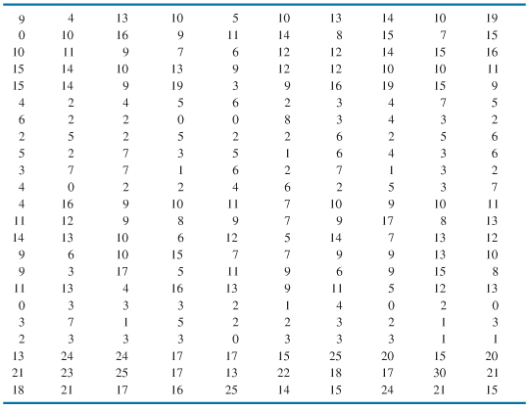

Can create frequency table based solely on values themselves because data is discrete….

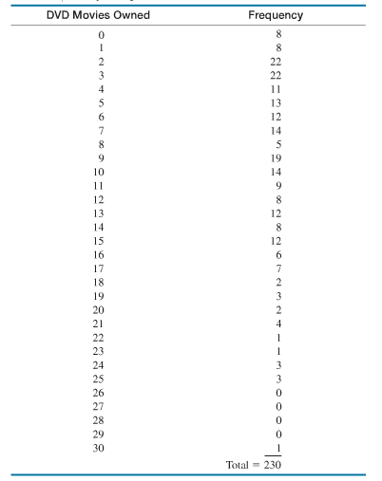
The Histogram would look like…..

Or can group data into classes of equal width

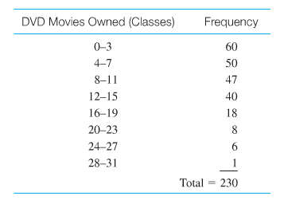

The Histogram would look like…

Using DDXL for Graphing Quantitative Data

- Dotplots and Histograms can also be done using DDXL

Excel Manual
Histogram – p 35 – 39
Dot plot - Follow instructions for Histogram on DDXL (p 35) choose Stacked Dot Plot instead of Histogram

What Can We Learn From Histograms, Dotplots, and Stem and Leaf?
- Center - It provides visual indication of where the approximate center of the data is.
- Spread - We can gain an understanding of the degree of spread (or variation) in the data. The more the data cluster around the center, the smaller the variation in the data.
- Shape – Is it reasonably flat, is it weighted to one side or the other, is it balanced around the center, or is it bell-shaped?

Example – Blockbuster Interpretation
- How many customers in the sample own more than 15 DVDs?

- What percentage in the sample own more than 15 DVSs?

- Which class has the most customers?

- Based on the shape of the histogram would you consider this most frequent class the center?

Which Graph Should We Use?
- The dot-plot and stem and leaf are more useful for small data sets. For larger data sets, histogram is usually better
- More flexibility is possible in defining the intervals with a histogram than in defining the stems
- Data value are retained in stem and leaf plot and dot plot but not with histogram

Shape of a Distribution

The distribution of the data is the values the variable takes and the frequency of occurrence of each value
- Described by Frequency Table
- Describing Overall Pattern – are they clustered together or is there a gap
- Mode – is there a single mound or is it bimodal?

Symmetric
  - The side of the distribution below a central value is a mirror image or the side above the central value
Skewed
  - One side stretches out longer than the other side
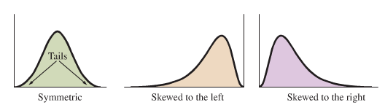

How Can We Describe the Center of Quantitative Data?

RECALL:
Parameter – Fixed about a population and is Typically Unknown
Statistic – Value calculated from the sample

Measures of Central Tendency

- Median - the middle of the data; 50th percentile
  - Observations must be in numerical order
  - Is the middle single value if n is odd
  - The average of the middle two values if n is even
NOTE: n denotes the sample size

- Mean - the arithmetic average
  - Use μ to represent a population mean
  - Use to represent a sample mean

- Mode – the observation that occurs the most often
  - Can be more than one mode
  - If all values occur only once – there is no mode
  - Not used as often as mean & median

Example - Suppose we are interested in the number of lollipops that are bought at a certain store. A sample of 5 customers buys the following number of lollipops. Find the median.
2 3 4 8 12

Suppose we have sample of 6 customers that buy the following number of lollipops. The median is …
2 3 4 6 8 12

Suppose we have sample of 6 customers that buy the following number of lollipops. Find the mean.
2 3 4 6 8 12

Using EXCEL

DDXL
- You can find these descriptive measures using the “Summary” in DDXL or whenever any graph is done

Excel Manual (using Data Analysis Tool pak)
- Measures of Center (p 46 – 48)
Excel Formulas
Mean: = AVERAGE()
Median: =MEDIAN()

Example - What would happen to the median & mean if the 12 lollipops were 20?
2 3 4 6 8 20
The median is…
The mean is…
What happened?

What would happen to the median & mean if the 20 lollipops were 50?

2 3 4 6 8 50
The median is…
The mean is …
What happened?

Resistant - Statistics that are not affected by outliers
  - Outliers are observations that fall well above or well below the overall bulk of the data

Is the median resistant?
Is the mean resistant?

Comparing the Mean and Median by Shape
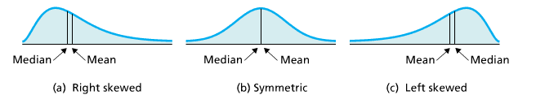

Example - Look at the following data set. Find the mean.
22 23 24 25 25 26 29 30

Now find how each observation deviates from the mean.

What is the sum of the deviations from the mean?

Example - Look at the following data set. Find the mean & median.

21 23 23 24 25 25 26 26 26 27
27 27 27 28 30 30 30 31 32 32

Create a histogram with the data. (use x-scale of 2) Then find the mean and median.

Mean =
Median =

Look at the placement of the mean and median in this symmetrical distribution.

Example - Look at the following data set. Find the mean & median.

22 29 28 22 24 25 28 21 25
23 24 23 26 36 38 62 23

Create a histogram with the data. (use x-scale of 2) Then find the mean and median.

Mean =
Median =

Look at the placement of the mean and median in this right skewed distribution

Example - Look at the following data set. Find the mean & median.

21 46 54 47 53 60 55 55 60
56 58 58 58 58 62 63 64

Create a histogram with the data. (use x-scale of 2) Then find the mean and median.
Mean =
Median =

Look at the placement of the mean and median in this left skewed distribution

RECAP:
- In a symmetrical distribution, the mean and median are equal.
- In a skewed distribution, the mean is pulled in the direction of the skewness.
- In a symmetrical distribution, you should report the mean!
- In a skewed distribution, the median should be reported as the measure of center!
Variability
Why is the study of Variability Important?
- Allows us to distinguish between usual & unusual values
- In some situations, want more/less variability
  - scores on standardized tests
  - time bombs
  - medicine

Measures of Variability
- range (max-min)
- interquartile range (Q3-Q1)
- deviations
- variance
- standard deviation

Example - Suppose that we have these data values:

24 34 26 30 37 16 28 21 35 29

Find the mean

Find the deviations

What is the sum of the deviations from the mean?

Square the Deviations:

Find the average of the squared deviations:

Variance
The average of the deviations squared is called the variance.

Population Parameter
Sample Statistic

Standard Deviation
A standard deviation is a measure of the average deviation from the mean.

Population Parameter
Sample Statistic
Using Excel

DDXL
  - You can find these descriptive measures using the “Summary” in DDXL or whenever any graph is done

Excel Manual (using Data Analysis Tool pak)
- Measures of Spread (p 49 - 50)

Excel Formulas
Sample Standard Deviation: =STDEV.S ()
Population Standard Deviaiton: =STDEV.P()
Sample Variance: =VAR.S()
Population Variance: =VAR.P()

Example - The following data was observed by a gym teacher, of the number of pull-ups by seventh graders at Edwards Junior High. What is the mean and standard deviation?

X
2
3
4
3
2
5
5
7
6
6
9
4
10
3
2
9

