**Chapter 3: Probability**

**Probability is really a different subject than Statistics however; we need to know the basics of probability if we want to do any sort of inference about populations. This chapter can be difficult for some students because there is not always only one way to do a problem. It all depends on the information you have any the information you want to know.**

**Experiment:** An act or process of observation that leads to a single outcome that cannot be predicted with certainty OR the process that produces outcomes

Example: For business

* Investment decision
* Personnel decision
* Choice of a warehouse

Examples of Experiments:

* Observe the up face on a coin
* Draw two marbles at random from a bag of black and red marbles
* Invest a stock
* Select an individual at random and observe their shoe size
* Shoot 5 free throws

**Sample Point:** The most basic outcome of an experiment

Examples (each individual outcome is a sample point):

* Observe the up face on a coin
  + Head, tail
* Draw two marbles at random
  + Red/Red, Red/Black, Black/Black
* Invest a stock
  + Stock increases, stock decreases, stock remains same
* Select an individual at random and observe their shoe size
  + …5,6,7,8,9,10,11,12,13,14,….
* Shoot 5 free throws (M = made it, X = missed it)
  + MXXXX, XMXXX, MMXXX, XXMXX, …

**Sample Space:** The collection of sample points of an experiment

Examples (entire collection of each)

* Observe the up face on a coin
  + Head, tail
* Draw two marbles at random
  + Red/Red, Red/Black, Black/Black
* Invest a stock
  + Stock increases, stock decreases, stock remains same
* Select an individual at random and observe their shoe size
  + …5,6,7,8,9,10,11,12,13,14,….
* Shoot 5 free throws (M = made it, X = missed it)
  + MXXXX, XMXXX, MMXXX, XXMXX, …

**Probability Rules for Sample Points**

Let *pi* represent the probability of sample point *i.*

1. All sample point probabilities must lie between 0 and 1 (0 ≤ pi ≤ 1)
2. The probabilites of all sample points within a sample space must sum to 1 ()

**Events:**

* Event - A specific collection of sample points.
* Simple Event - on a single sample point
* Compound Event – collection of two or more sample points

**Examples:**

* **Observe the up face on a coin**
* **Draw two marbles at random from a bag of black and red marbles**
* **Invest a stock**
* **Select an individual at random and observe their shoe size**
* **Shoot 5 free throws**

**Probability of an Event:**



**Example: Olympic Medal**

|  |  |
| --- | --- |
| **Country** | **Count** |
| United States (U) | 104 |
| China (C) | 88 |
| Russia (R) | 82 |
| Great Britain (GB) | 65 |
| Other (O) | 623 |
| TOTAL | 962 |

**What is the probability a randomly selected medal is from United States?**

**What is probability a randomly selected medal is from Russia or Great Britain?**

|  |  |  |  |  |
| --- | --- | --- | --- | --- |
|  | **Gold (G)** | **Silver (S)** | **Bronze (B)** | **Total** |
| **United States (U)** | 46 | 29 | 29 | 104 |
| **China (C)** | 38 | 27 | 23 | 88 |
| **Russia (R)** | 24 | 26 | 32 | 82 |
| **Great Britain (GB)** | 29 | 17 | 19 | 65 |
| **Other (O)** | 165 | 366 | 253 | 623 |
| **TOTAL** | 302 | 304 | 356 | 962 |

**What is the probability a randomly selected medal is gold?**

**What is the probability a randomly selected medal is won by Russia?**

**What is the probability a randomly selected was silver AND won by the United States**

**What is the probability a randomly selected medal is bronze or won by China?**

**Union:** If either A or B or both occurs on a single performance of the experiment

**What is probability a randomly selected medal is from Russia or Great Britain?**

**What is the probability a randomly selected medal is bronze or won by China?**

**Intersection:** If both events A and B occur on a single performance of the experiment

**What is the probability a randomly selected was silver AND won by the United States**

**Additive Rule of Probability:**



**What is the probability a randomly selected medal is bronze or won by China? Using Additive Rule**

**Mutually Exclusive:** If A∩B contains no sample points – that is A and B have no points in common

**Are the following pairs mutually exclusive events?**

* + **U and G**
  + **C and R**
  + **G and GB**
  + **G and S**
  + **O and U**

**Additive Rule for Mutually Exclusive Events**

**If** A and B are mutually exclusive **Then**



**Therefore…**



**Becomes…**



**Complement:** The complement of an event *A* is the event that A does *not* occur – that is, the event consisting of all sample points that are not in event *A*.



**Examples:**

* **G = gold medal GC = silver or bronze medal**
* **U = won by US UC = all other countries   
   {China, Russia, Great Britain, and Other}**

**New Example:** The table below shows the results of a survey of online video viewing by age**.**

|  |  |  |  |
| --- | --- | --- | --- |
|  | **Type of Videos Preferred** | |  |
| **Viewer Age** | **User Created** | **TV** |  |
| **18-34** | **39** | **30** | **69** |
| **35-54** | **10** | **10** | **20** |
| **55+** | **3** | **8** | **11** |
|  | **52** | **48** | **100** |

**What is the probability that a viewer is aged 18-34?**

**What is the probability that a viewer prefers watching TV videos?**

**What is the probability of viewers who are 18-34 and prefer watching user-created videos?**

**What is the probability of viewers who are 35-54 or prefer user created videos (use addition rule)?**

**Are the following pairs of events mutually exclusive?**

* **18-34 and 55+**
* **User Created and 35-54**
* **Below 54 and 55+**
* **18-34 and Below 54**

**What is the complement of the following events?**

* **A = User Created**
* **B = 35 or older**
* **C = 55+**
* **D = User Created and Younger than 55**

**Conditional Probability:** Probability of an event *B* given information about another event *A.*



Read as “ Probability of B given A”

**Example: Olympic Example**

|  |  |  |  |  |
| --- | --- | --- | --- | --- |
|  | **Gold (G)** | **Silver (S)** | **Bronze (B)** | **Total** |
| **United States (U)** | 46 | 29 | 29 | 104 |
| **China (C)** | 38 | 27 | 23 | 88 |
| **Russia (R)** | 24 | 26 | 32 | 82 |
| **Great Britain (GB)** | 29 | 17 | 19 | 65 |
| **Other (O)** | 165 | 366 | 253 | 623 |
| **TOTAL** | 302 | 304 | 356 | 962 |

**Given a randomly selected medal is Gold what is the probability that the medal was won by the US?**

**What is the probability that a medal won by China is Bronze?**

**Example: Video Example**

|  |  |  |  |
| --- | --- | --- | --- |
|  | **Type of Videos Preferred** | |  |
| **Viewer Age** | **User Created** | **TV** |  |
| **18-34** | **39** | **30** | **69** |
| **35-54** | **10** | **10** | **20** |
| **55+** | **3** | **8** | **11** |
|  | **52** | **48** | **100** |

**Given that a randomly chosen viewer prefers to watch TV, what is the probability that the viewer is 55+?**

**What is the percentage of viewers aged 18-34 who prefer watching user created videos?**

**Independent Events:** Events A and B are independent events if the occurrence of B does not alter the probability that A has occurred.



If events are not independent they are **dependent.**

**Example: Olympic Example**

**Are the events G and U independent?**

**Example: Video Example**

**Are the events User Created and 55+ independent?**

**Multiplication Rule:**



**Multiplication Rule if A and B are independent**

IF *A* and *B* are independent THEN…



THEREFORE…



BECOMES…



**Probability Rules**

Addition Rule:



Complement Rule:



Conditional Rule:



Multiplication Rule:



Sequential Events: When trying to find the probability of sequential events the probability rules that you have learned can be useful…

**For Example:**

|  |  |  |  |  |
| --- | --- | --- | --- | --- |
|  | **Gold (G)** | **Silver (S)** | **Bronze (B)** | **Total** |
| **United States (U)** | 46 | 29 | 29 | 104 |
| **China (C)** | 38 | 27 | 23 | 88 |
| **Russia (R)** | 24 | 26 | 32 | 82 |
| **Great Britain (GB)** | 29 | 17 | 19 | 65 |
| **Other (O)** | 165 | 366 | 253 | 623 |
| **TOTAL** | 302 | 304 | 356 | 962 |

1. **If two medals are randomly selected what is the probability that the 1st selected is gold and the 2nd selected is silver?**
2. **If two medals are randomly selected what is the probability one is gold and one is silver?**

**Example:** In a bag of peanut M&M’s, there are 80 M&M’s, with 11 **red** ones, 12 **orange** ones, 20 **blue** ones, 11 **green** ones, 18 **yellow** ones, and 8 **brown** ones. They are mixed up so that each candy piece is equally likely to be selected if we pick one.

1. **If we select one at random, what is the probability that it is red?**
2. **If we select one at random, what is the probability that it is not blue?**
3. **If we select on at random, what is the probability that it is red or orange?**
4. **If we select one at random, then put it back mix them up well and select another one, what is the probability that both the first and second ones are blue?**
5. **If we select one, keep it and then select a second one, what is the probability that the first one is red and the second one is green?**

**Tree Diagrams:** Sometimes it is useful to use a tree diagram in order to fully see the sample space…

To create a tree diagram:

* Each level represents the outcomes for each event
* There are multiple branches per level which represent the potential outcomes for each
* The sum of the probabilities from each node should add to 1.

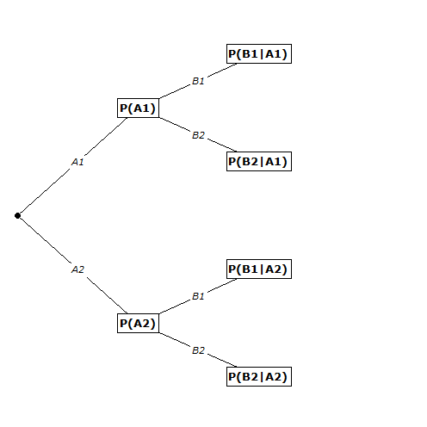

**Example: Olympic Example**

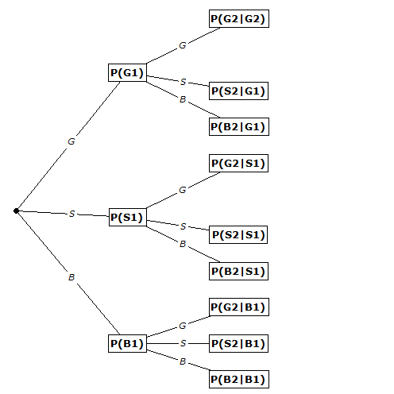

**Example:** Men have a reputation for not wanting to ask for directions. A Harris study conducted for Lincoln Mercury indicated that 42% of men and 61% of women would stop and ask for directions. The US Census Bureau’s 2007 population estimate was that for individuals 18 or over, 48.2% were men and 51.8% were women. This exercise addresses this age group.

Create a tree diagram for this example.